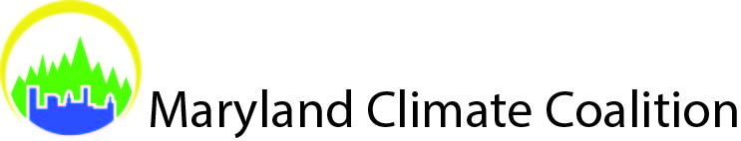

Maryland Climate Coalition Mini-Grant Proposal Application

Guidelines: Project/Initiative must connect with the Maryland Climate Coalition mission “to unite Marylanders to mitigate climate change to protect our environment, health, and economy.” Examples of projects we will consider include, but are not limited to: local events that educate about how climate issues impact our lives and offer tools for action; community organizing and community outreach initiatives that promote Maryland doubling its commitment to clean energy and/or renewing and strengthening Maryland’s Greenhouse Gas Reduction Act; and targeted efforts to engage new constituencies (e.g. labor, faith groups, civil rights organizations, low-income advocates, business, environmental justice, etc.) in helping make Maryland a national leader in climate policy.

All proposals should be electronically submitted as a Microsoft Word attachment by email to hartungt@nwf.org. Proposals will be considered on a rolling basis until April 20th. Applicants will be notified within two weeks of submission.

Title of Project

Population Served

Geographic Area Served

Please answer below:

- Description of Proposal (250 word limit)
Please provide a short description summarizing your project. How does this project address our efforts to educate and mobilize Marylanders in support of innovative and effective solutions to combat climate change? Include what you hope to achieve, measurable goals, and how you will evaluate success.

- Time frame (200 word limit)
On what date or dates would your proposed project take effect and be completed?

- Relevance & Partnership (200 word limit)
A top priority of the Maryland Climate Coalition is to increase our state’s Renewable Portfolio Standard (which requires electricity suppliers to buy a growing share of their power from renewable sources) from the current goal of 20% renewable sources of energy purchased for use in Maryland by 2025 to double that number. Renewing and strengthening Maryland’s Greenhouse Gas Reduction Act (GGRA) in 2016 also a priority of the Coalition. The GGRA directed Maryland to create a Climate Action Plan that uses science-based reductions in statewide carbon pollution. As part of your project/initiative, how do you envision partnering with our Coalition to promote these goals?

- Funds Requested—Awards of up to a maximum of $1,000 will be considered. Awards will be distributed in increments of $500, $750 or $1,000 (200 word limit)
Indicate total amount requested for this project, breakdown of total cost, basis for the cost(s) estimate.

Signature Date
Organization Name/ Title of Requestor

