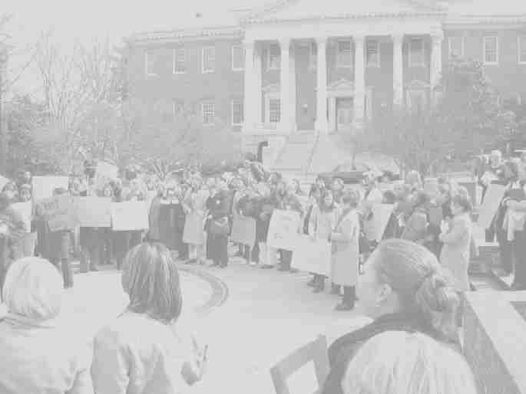

The National Association of Social Workers, Maryland Chapter
Social Work Students’
The
Power of
Social Work

Advocacy Day in Annapolis

Thursday, February 28, 2013, 8:30 AM – 3:00 PM

Miller Senate Building, Annapolis, MD

PROGRAM

8:30 am – 9:00 am President’s Conference Room East, Miller Senate Bldg.
Arrival and Registration

9:00 am – 9:30 am Welcome and Review of Agenda
- Daphne McClellan, Ph.D., MSW, Executive Director, NASW-MD
9:30 am – 9:45 am Walk to Lawyer’s Mall

9:45 am – 10:30 am Rally at Lawyer’s Mall with Healthcare for the Homeless
OR
Discussion of “Analyzing Legislative Language” in President’s Conf. Room
Gisele Ferretto, MSW

10:30 am- 10:45 am Folks at Rally return to President’s Conference Room

10:45 am -12:00 pm Keynote Address on Gun Violence and Legislative Update
Speaker TBA
Ann Ciekot, Michele Douglas NASW Lobbyists
12:15 pm – 1:00 pm Lunch with Legislators in Lowe House Bldg, Room 170 & 180
1:00 pm – 3:00 pm a) Attend Committee Hearings (various committee rooms) OR
b) Visit legislator’s offices OR
c) Workshops
1:00-1:45 “Legislative Advocacy through Social Media
Media” Room 180 HOB*
Speaker TBA
1:45-2:30 “Death Penalty” Room 180 HOB*
Speaker TBA

*HOB- Lowe House Office Building

These Rally Themes!!!
CHECK IT OUT... www.nasw-md.org

