Volunteers needed for research study.

The Role of Skin Color & Hair Politics
in Black Women’s College Experiences

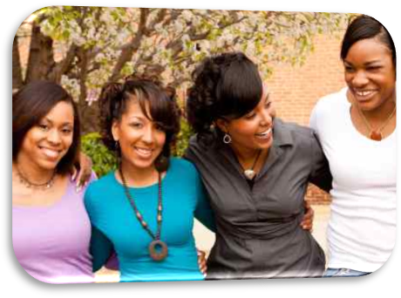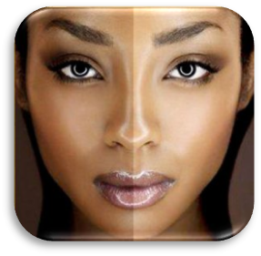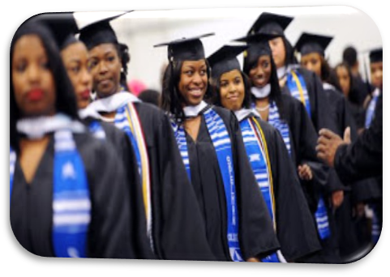

I am a graduate student, in the UMBC Language, Literacy, & Culture doctoral program, conducting research to explore the ways in which Black, female, undergraduate students’ experiences are impacted by hair and skin hue politics within campus culture. Please contact me for more information if you meet the following eligibility criteria and are interested in participating:

- Black/African American
- Female
- 18-25
- Enrolled at UMBC full-time

You will be asked to share your on and off campus experiences, as they relate to hair and skin color, individually or in a small group setting of no more than twelve students for participation in a focus group. Focus Group participants will receive a free pizza dinner. Individual Interview participants will receive $20 cash.
Latasha Eley  leley1@umbc.edu - 757-777-6173 | Latasha Eley  leley1@umbc.edu - 757-777-6173 | Latasha Eley  leley1@umbc.edu - 757-777-6173 | Latasha Eley  leley1@umbc.edu - 757-777-6173 | Latasha Eley  leley1@umbc.edu - 757-777-6173 | Latasha Eley  leley1@umbc.edu - 757-777-6173 | Latasha Eley  leley1@umbc.edu - 757-777-6173 | Latasha Eley  leley1@umbc.edu - 757-777-6173 | Latasha Eley  leley1@umbc.edu - 757-777-6173 | Latasha Eley  leley1@umbc.edu - 757-777-6173 | Latasha Eley  leley1@umbc.edu - 757-777-6173

