Emergency Preparedness Training

Wellness Workshop for Faculty, Staff, and Students

Want to know what to do in the event of a campus emergency?

Interested in learning what plans are in place and how to respond in each emergency situation?

Tuesday  September 18, 2012  3:30 – 5:00 pm  The Commons Room 331  Presenters:  Mark Sparks  Chief of Police  Paul Dillon  Deputy Chief |  | This 90-minute training is designed to help prepare members of the campus community for the multitude of critical incidents that could affect our campus. This interactive course will explore in detail how the UMBC Police and other departments are prepared to respond in an emergency.  Participants will be provided with critical information on how to prepare for and respond in a true emergency.  Topics covered will include:  - Responding to weather emergencies.  - What to do during an “active shooter” incident.  - Evacuation procedures.  - Understanding of how to best use the emergency communication systems.  - Responding to utility emergencies.  - Responding to fires, HAZMAT or CBRNE incidents.
Please join us for this critical training that just could save your life. Staying well starts with staying safe!
Register on the web by September 16th at: www.umbc.edu/training
Spaces are limited and pre-registration is required. Contact Paul Dillon at pdillon@umbc.edu for more information
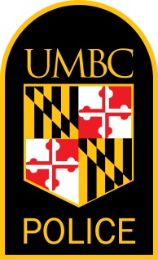 | 

