# Understanding

# Classification & Compensation:

# ***HR Guide to Position & Salary Administration***

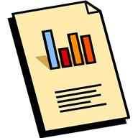

Join the Department of Human Resources for an informative overview of the functions of the Classification & Compensation Unit and the key factors that make up UMBC’s classification & compensation program.

HR Business Process Workflow

Creating and Reclassifying Positions

Salary and Wage Administration

Organizational Development Services

Position Management

Resources for Managers and Payroll Approvers/Preparers

Thursday, November 30, 2017, 12:00 p.m. to 1:00 p.m.

University Center Ballroom Lounge

Visit the [**UMBC Training page**](http://my.umbc.edu/groups/training/events) to register

**LIGHT REFRESHMENTS WILL BE SERVED**