Introduction to PeopleSoft Finance Fundamentals
Training Manual
Financial Services | 6/27/19 | Version 2.0

Contents
Contents 1
1 Introduction 3
2 Security Access 3
2.1 Account Information – Chartfields 4
3 Commonly used Chartfields 4
4 Navigation 5
4.1 Logging In 5
4.2 Landing Page - Employee Self Service 5
4.3 Navigating with Breadcrumbs 6
4.4 Navigating with Navigator 8
5 Favorites 9
5.1 Navigation 9
5.2 Add Favorites 9
5.3 Delete Favorites 10
6 Workcenters 11
6.1 Overview 11
6.2 Navigation 11
6.3 My Work Section 13
6.4 Links Section 14
6.5 Queries Section 15
6.6 Reports Section 15
7 Approvals 15
7.1 Navigation 15
7.2 Approve the Transaction 17
8 Reports 18
8.1 Differences Between Reports and Queries 18
8.2 Reporting Basics 18
8.3 Run Control ID? 19
8.4 Add a Run Control ID 19
8.5 Specifying Search Criteria 19
8.6 Running the Report 20
9 Queries 23
9.1 Using a Query 23
10 REX Financial Reports 25
10.1 25
11 Getting Help 25
11.1 Receiving Updates via E-mail 25
11.2 UMBC RT Help Desk System 25
11.3 Links Associated with PeopleSoft 26
12 Next Steps 26
13 Appendix 26
13.1 Financial and HR Terminology 26
13.2 Common Navigation Icons 27

Introduction
There are three different PeopleSoft environments that you may interact with here at UMBC.
Finance: https://financialservices.umbc.edu
This database stores information related to departmental financial activities. You can use this database to process and locate: P-card transactions, Journal Entries, Grants, Projects, Accounts Payable and Accounts Receivable activities, General Ledger and other financial activities.
Human Resources: https://hr.umbc.edu
PeopleSoft Human Resources, which is used to enter and report on human resource activities, such as Payroll.
Student Administration: http://enrollment.umbc.edu/sa/
Student Administration which consists of Student Recruitment, Admissions, Student Records, Financial Aid, Student Billing, and Academic Advisement

Security Access
Before you can use PeopleSoft, you are granted security access rights into the application. Your security access is dependent upon your role within UMBC. You can be granted several different access rights into PeopleSoft for each database as well as each form or table in the application. The different types of access rights you may receive include:
No Access: If you have no access to a particular area of the application, you will not be able to see an option on your PeopleSoft work center. For example, if you do not work with Grants, you will not be able to see the Grants menu option.
View Only Access: if you have view only access to an area of the application, you will be able to see the option on your PeopleSoft menu, but you would only be able to view the information on the screen. Most reports in PeopleSoft are view only, which means you are unable to effect the information in the database, regardless of the buttons or actions you take with the report
Edit Access: If you have been granted edit access to an area of the application, you will be able to input information into the application. Depending on the level of edit access you have been granted, you may or may not be able to also delete information.
If you require a level of access that you do not have in the application, please complete a Security Access Form and return it to the appropriate team for processing. Instructions for completing the form and where to send it for processing are included in the security form information section of the website.

Account Information – Chartfields
In order to process a transaction in PeopleSoft, users must use codes called Chartfields. Chartfields are informational fields that categorize transactions and apply the transactions to budgets.
A series of chartfields is referred to as a Chartstring. Every action in PeopleSoft requires a Chartfield String in order to submit paperwork and enter, research, and interpret data in the PeopleSoft databases.
Chartfields and Chartfield Strings are required to:
- Generate reports
- Access data
- Perform transactions in PeopleSoft
- Complete forms
- Allocate expenses
When departments make purchases, allocate expenses, and receive revenue, all paperwork associated to these activities requires that the appropriate chartfields be completed in order for the Finance Departments to process the paperwork.
There are 10 chartfields in PeopleSoft Finance, however, not all chartfields are required for every transaction. Some chartfields are specific to grants or sponsored accounts.
For example, chartfields associated to General Ledger transactions are commonly referred to as GL Chartfields. The Chartstring for the GL includes:
- Business Unit
- Department
- Fund Code
- Account
- Prog Fin
- Fiscal Year

Commonly used Chartfields
Chartfield | Example | Definition
Business Unit | UMBC1 (all PS 9.2 Finance transactions are under the default) | A set of financial records, business practices and reporting requirements
Department ID | 10118 – New Media | An organizational unit responsible for business transactions
Fund | 1111 = State Fund  1113 – Self Supporting Fund (DRIF)  1253 = Grant Fund | Identifies the source of UMBC funding
Account | Revenue – 4XXXXXX  Payroll – 6XXXXXX  Operating Costs- 7XXXXXX | Classifies business transactions by categories that include assets,  liabilities, net asset (fund balance), revenue and expenditures.
Project/Grant | 00000444 CASPR | Provides link for financial transactions to the grant management database
Prog Fin  (Program Financial) | 011- Instruction- General  012 Instruction- Special  021 Research Institutes/Centers  022 Research – Individual | Codes that categorize the expenses. All department budgets have been created with specific Prog Fins to be applied to transactions

Navigation

Logging In
To log into PeopleSoft Finance, you can go directly to https://fsprd-web.psfs.umbc.edu/WebAuth
When booking the above as a bookmark, be sure to copy and paste that url directly into the bookmarks toolbar. If you try to favorite after clicking enter, the URL changes and if saved, it will not work as a login link after.
You can also find a link to PeopleSoft Finance on the my.umbc.edu website. After logging in, look for the Trending links just under the main banner in the middle. PeopleSoft: Finance is listed in those links. You can also look for it using the search tool on the my.umbc.edu website.
When logging in, use your normal UMBC credentials.
Please note that PeopleSoft will automatically time out if there is no activity for 120 minutes. It is important that all work is saved before that timeout occurs.

Landing Page - Employee Self Service
The navigation in PeopleSoft 9.2 has seen a drastic improvement in comparison to the 8.9 menu navigation.
In an effort to make PeopleSoft more mobile and user friendly, they have rolled out a menu option of tiles. Tiles mostly point to various WorkCenters, but can also point to heavily used menu options, such as Approvals.
The tiles appear on a page called Employee Self Service. This is the default page you will see when logging into PeopleSoft.

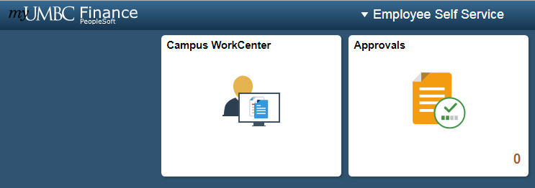
All campus users can use the Campus Workcenter to access everything that they regularly use in PeopleSoft. Departmental Approvers and Central Employees may also see a tile called Approvals.
If you see additional tiles, it means that you have more of a centralized role. Use those tiles to access menu options that relate to central tasks.
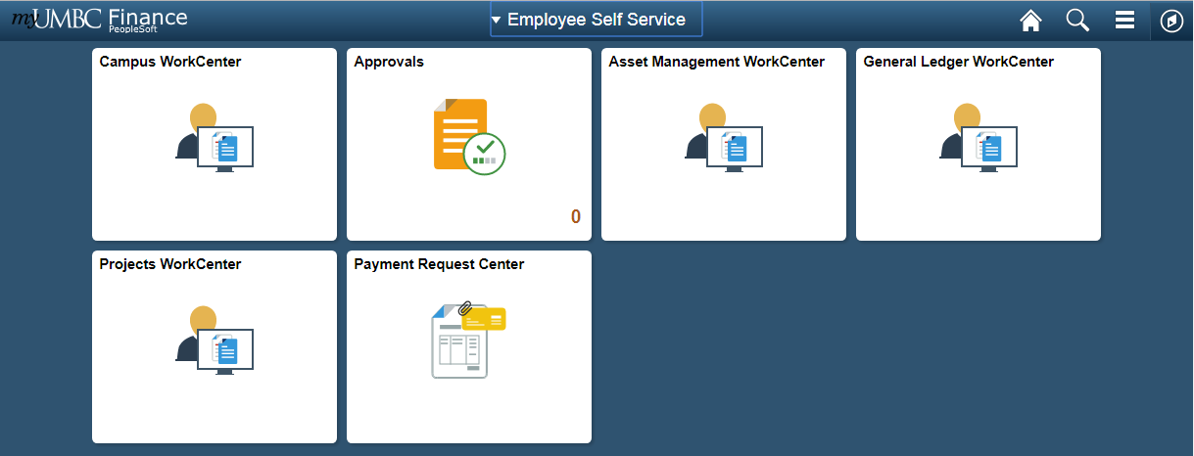
Note: Your WorkCenter is configured based on your security access, therefore there may be less tiles. All PeopleSoft Finance users will have the tile labeled Campus WorkCenter.

Navigating with Breadcrumbs
Once inside a workcenter, you will also notice that a top menu bar appears, showing breadcrumbs of where you’ve been.
This is an interactive bar that shows menu options in the same order as they appeared in 8.9.
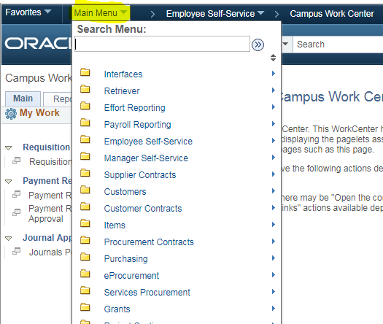

Navigating with Navigator
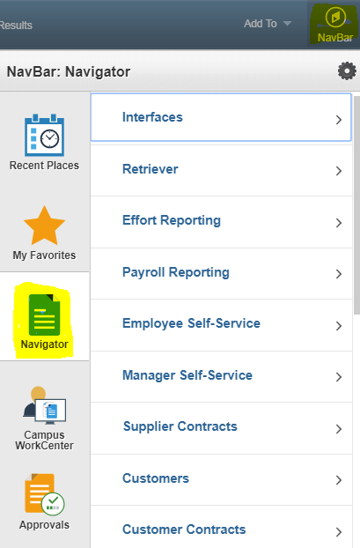
If you do not see the breadcrumbs at the top of the page (sometimes they are unavailable), you can access the menu options by clicking on the compass symbol called NavBar in top right hand corner of every page. This will bring up a side menu bar.
From there, click on the Navigator Menu option. This will bring up the main menu options in the same order that they appear in 8.9.

As a general tip, if you drill down to a specific menu option, the next time you go into Navigator it will “remember” the last menu option you drilled down to. So you may have to hit the back bar at the top of the navigator menu tree to see the main menu options again.

Favorites

Navigation
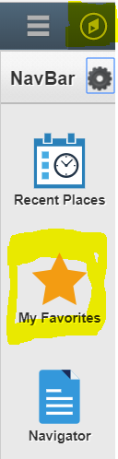
You can get to your favorites by clicking on the NavBar icon in the top right hand corner of any page, which looks like a compass.
This will bring up a right hand side menu, and Favorites will be the second tile on this menu.

Add Favorites
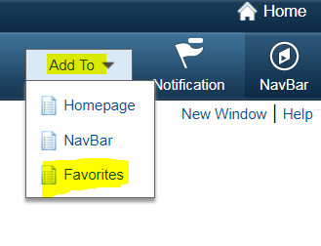
To add to your Favorites, go to the page that you would like to add. Once there, look at the top bar on the right hand side. Select the dropdown arrow next to “Add To” and select Favorites.

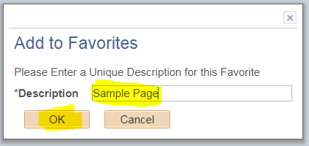
Edit the Description (if needed) and click OK
You will now see this link in your favorites when you navigate to them.

Delete Favorites
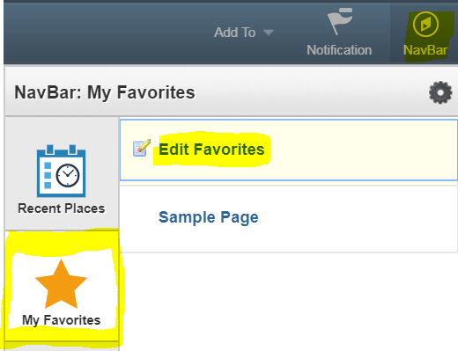
To delete favorites, go to the Favorites tile from the NavBar. After clicking on the tile, an additional side menu appears. Click on the top link that says Edit Favorites
From there it will bring you to a page that lists out all your Favorites. Click on the box with a – sign next to the favorite you would like to delete.

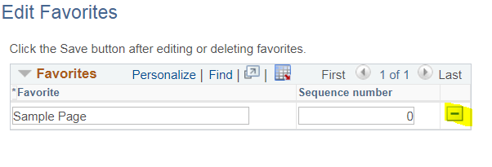
Click OK to the delete confirmation message.
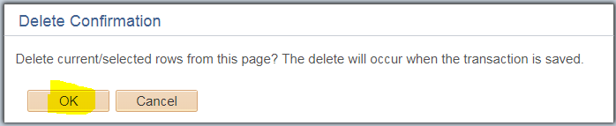
You will no longer see that Favorite in your Favorites bar.

Workcenters

Overview
Workcenters are designed to replace the old navigation seen in PeopleSoft 8.9 and before, to group together menu options regularly used based on your role in PeopleSoft. They reduce navigation time and let you accomplish your daily tasks in an efficient manner.

Navigation
All Workcenters are divided into four general areas, called pagelets. On the left-hand side you will see the navigation bar, with two tabs, and two sections on each tab.
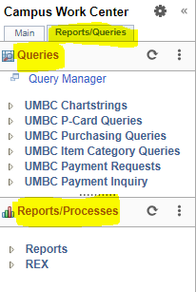
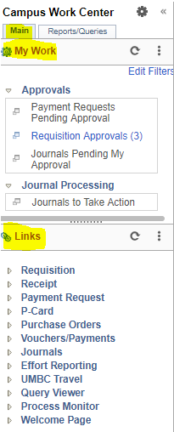

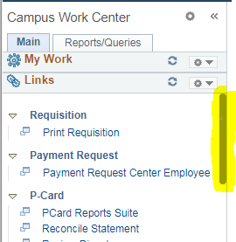
There are additional navigational tools for the pagelets that appear when your cursor hovers in the area: one is a right-hand vertical scroll area. You can left-click the scroll once it appears, hold down the cursor and drag the scroll bar up or down.
You can also resize each Workcenter pagelet. Just hover over the dotted line in each pagelet until the cursor turns into a double-sided arrow. Left-click and hold down. Drag and drop up or down to resize the pagelet.

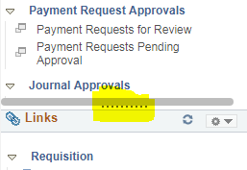
To collapse any of these sections so that you can focus on the sections that matter to you, select the dropdown arrow next to the gear icon, to the right of the section title. Select Minimize.

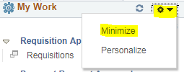
To expand the section, select the dropdown arrow next to the gear icon again, and select expand.

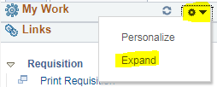
When clicking on any menu item, the page that correlates to that link displays next to the menu on the right hand side. You can hide the left hand menu options to give more real estate for the page you are actively working on. To do this, click on the << symbol at the top of the menu bar next to the Workcenter name.
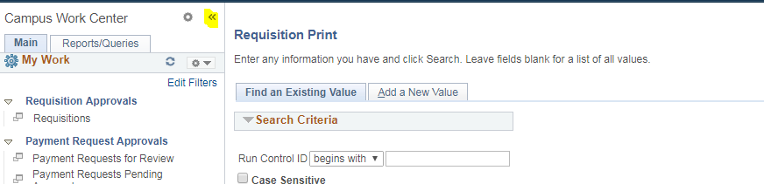
To get the menu back, simply select the >> icon (now in the top left hand corner of the page):
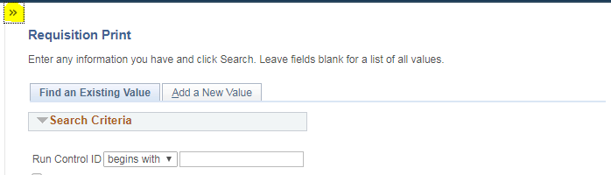

My Work Section
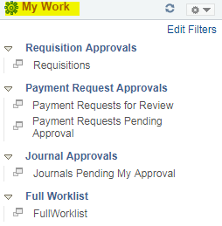
On the main tab, you will see a My Work section with hyperlinks to task pages.
The My Work pagelet can include links to events and notification alerts, prioritized items needing immediate attention, and worklist tasks for workflow approval.
The hyperlinks ONLY become active when you have tasks to complete in that section. Otherwise, the hyperlink is grayed out and you cannot click on it. Hyperlinks are only visible to a user if they have access to the corresponding pages they link to.
When a user has work to do, the hyperlink becomes clickable. A number will display in parenthesis next to the link letting you know how many items require attention.

Links Section
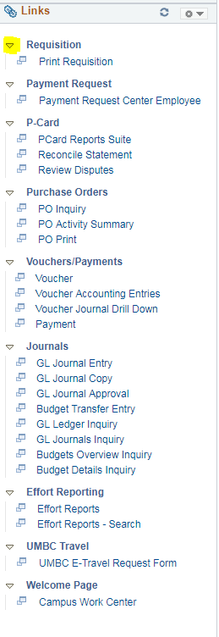
The Links pagelet makes it possible for you to access your most commonly-used pages with full functionality without ever leaving your Workcenter.
Each pagelet can include group headings. Group headings are used to place similar pages and links into logical groupings, and are expandable and collapsible.
The group headings themselves are not clickable. You have to select the dropdown arrow next to the group heading to expand the menu options, which opens up all links related to that group heading. Those links are clickable.
The Links pagelet can include additional links to pages and other areas of interest including links that are external to your organization.
You can personalize (from the list enabled by your system administrator) which links appear on your Workcenter.

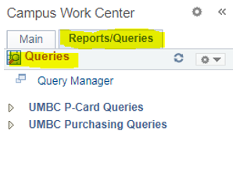
Queries Section
The Queries pagelet can include links to Query Manager, public queries, and pivot grids.
If there is a Query that you think will benefit the campus, you can reach out to IT to have a link added to the Campus Workcenter.
All queries that show up in the Workcenter will be available to everyone, so we cannot configure it for the individual user.
However, you can also view all your query favorites when you go to the Query Manager.

Reports Section
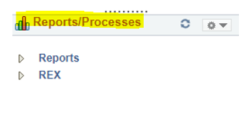
The Reports Pagelet an include links to reports frequently used by the campus. Examples include PCard Reports suite, and all REX reports.
These links take you directly to the Run Control page for the report or process.
There is a REX app that allows you to see and run REX reports within the PeopleSoft environment (only works in Internet Explorer).
If there is a Report that you think will benefit the campus, you can reach out to IT to have a link added to the Campus Workcenter.

Approvals

Navigation
If you need to approve an item as a departmental approver: Go to the Employee Self Service Page and click on the Approvals Tile.
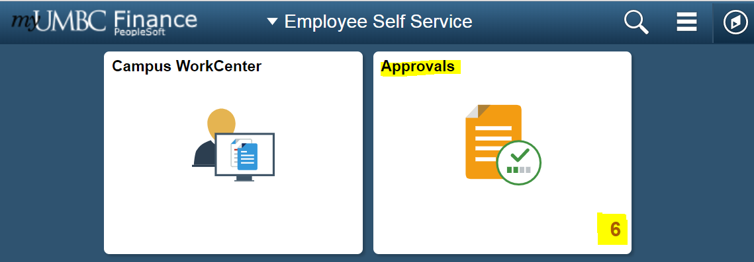
All items requiring your approval are listed here. You can select on the left hand side which area you would like to work with (i.e. Journal Entries, Payment Requests, Budget Transfers, Requisitions, etc.)
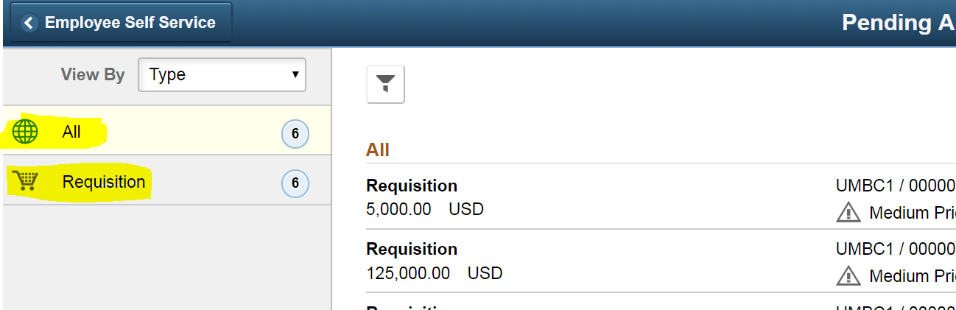

Once filtered down, select the item from the list that you would like to approve. The item name, number (ID) and the person who submitted it can be seen from the review list.

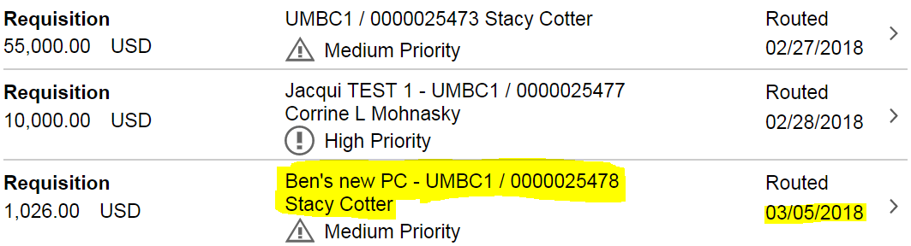
Click on the link of the Requisition you would like to review.

Approve the Transaction
To approve or deny the item, fill in the appropriate comments into the Approver Comments section at the bottom, and select Approve or Deny in the top right hand corner
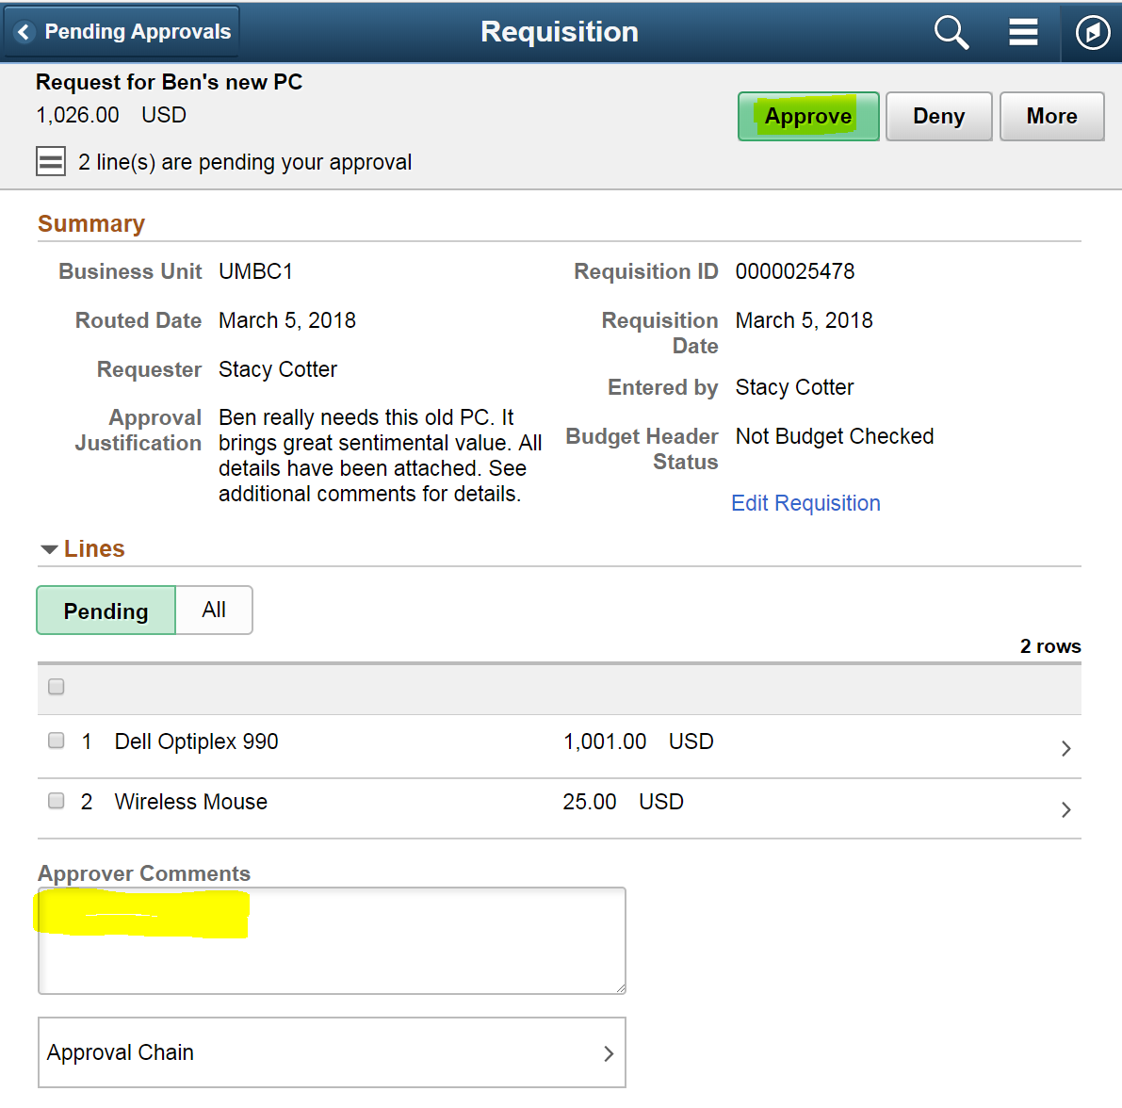
A popup will appear with your approver comments pre-loaded in it. Change your comments if needed. Click Submit.
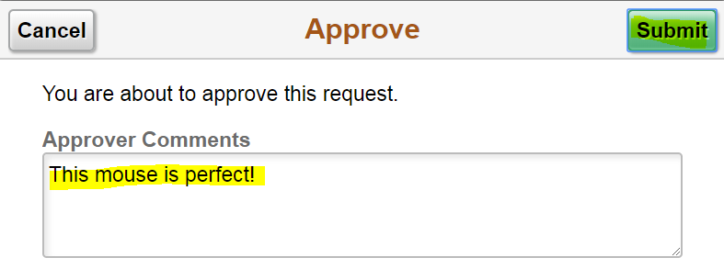
After approving it will go through central approval and disappear from your worklist.

Reports
This section will teach you the basics in how to run basic and advanced reports in PeopleSoft:
- Discuss the difference between Reports and Queries in PeopleSoft
- Create a New Run Control ID, and use Existing Run Control IDs
- Enter Search Criteria (parameters) to return data in PeopleSoft.
- Perform the steps to run a report.
- REX Finance Reports

Differences Between Reports and Queries
While using PeopleSoft, you will be using reports and queries to view information.
Reports allow you to filter a large amount of data by specifying chart fields. Report data can be downloaded into an Excel or PDF file.

Queries typically require specific data to extract information from the database e.g. the PO #. A query is used to return very specific information to the user.

Reporting Basics
When running reports in PeopleSoft, there are basic steps that are performed each time. This section will walk you through the basics for running a simple report in PeopleSoft.
The following examples will use the Transaction Detail by Department Report, located in the Financial Retriever and Reports database.

Run Control ID?
When requesting a report in PeopleSoft, you must enter the parameters from which the report will be run, and eventually display data for you to view. To aid in running reports, PeopleSoft created a means to allow the user to save search parameters so he/she does not have to perform the same steps each time the same report is requested. Run Control IDs are how PeopleSoft identifies saved search parameters for reports.

Add a Run Control ID
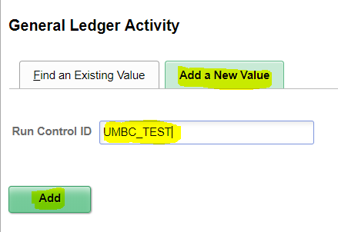
For this example, we will be adding a run control for the General Ledger Activity report. You can find this report in the Reports section of the Campus Workcenter.
Click the Add a New Value tab.
Enter a name for the Run Control ID. The name cannot contain any spaces. However, you can use the underscore key _ to separate words within the run control ID.
Click the Add Button .

Once you create a Run Control ID, you cannot change it. Hence, your Run Control ID should represent the report you will be running.
Run Control IDs are unique to the database in which they are created. Therefore, Run Control IDs created in PeopleSoft Finance are not available in any other PeopleSoft database.

Specifying Search Criteria
After clicking add you will be brought to a page that allows you to enter data to narrow the search criteria. This information will get saved with your run control ID, so that you do not have to enter the data each time you run the report – only the first time.
In this case, Unit is pre-populated, as is the Ledger. You can enter the fiscal year, period, chartfields, etc. as a method to tailor the data to meet your reporting needs.
If you are not sure what your options are for a given field, you can use the magnifying glass to search.
Business Unit = UMBC1. This is the default for all PeopleSoft transactions at UMBC.
The Accounting Date Range must have a start and end date for the reporting data.
NOTE: The Fiscal Year spans July 1, 20xx June 30, 20xx (i.e., FY 2020 is July 1, 2019 through June 30, 2020)
If you are unsure about a particular chart field, use the button to search for that specific chart field.
When you are finished entering the search criteria, click save.
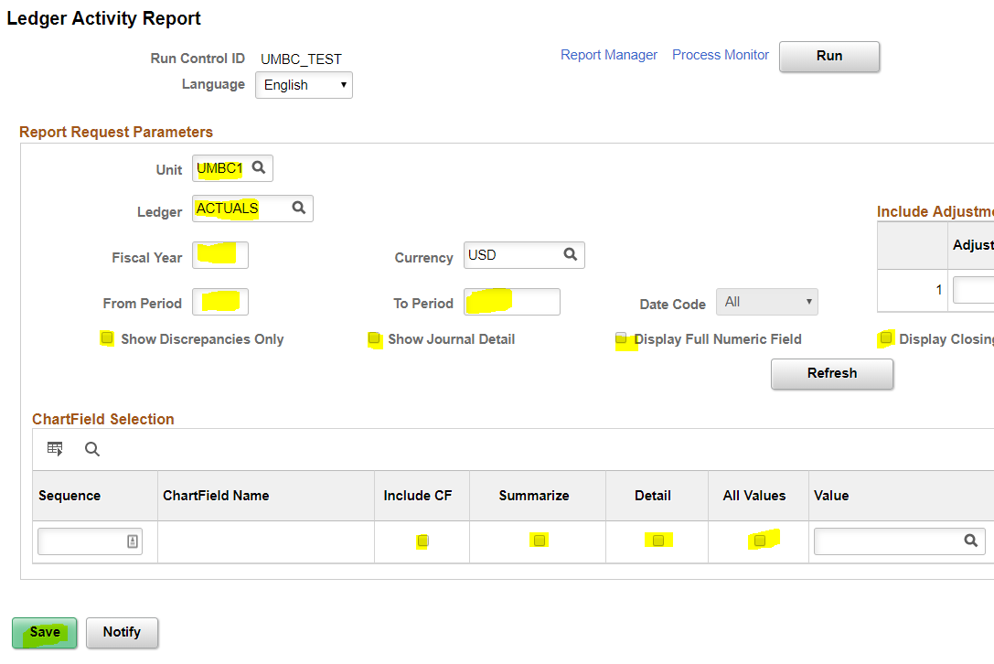

Running the Report
Once the Search Parameters have been entered, you are ready to run the report.
Click the Run button.
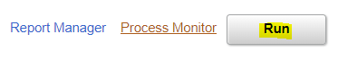

The Process Scheduler Request screen displays.

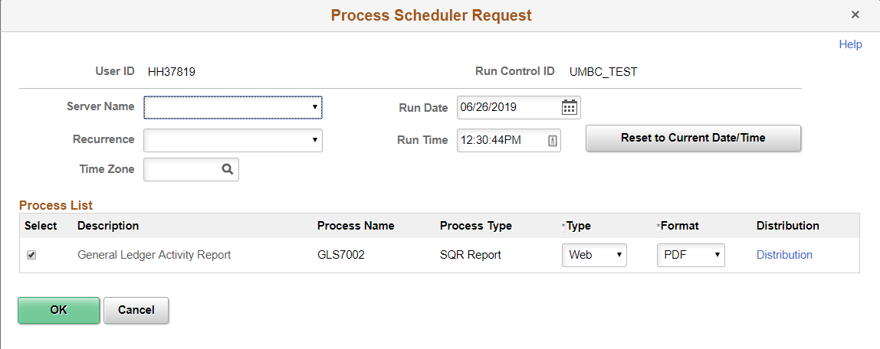

Do not edit any information on this page. Click OK. You will get a message that the page is saving, and then it returns you to the previous page where you selected your run control data.
From here, click on the Process Monitor button (right next to the run button) to check on the status of your recently run report.
Pay attention to the run status. If it still says processing, you can click the Refresh button periodically until it updates to Success. If it runs to no success or error, feel free to reach out for help. Steps to submit a ticket are included in the help section of this document.
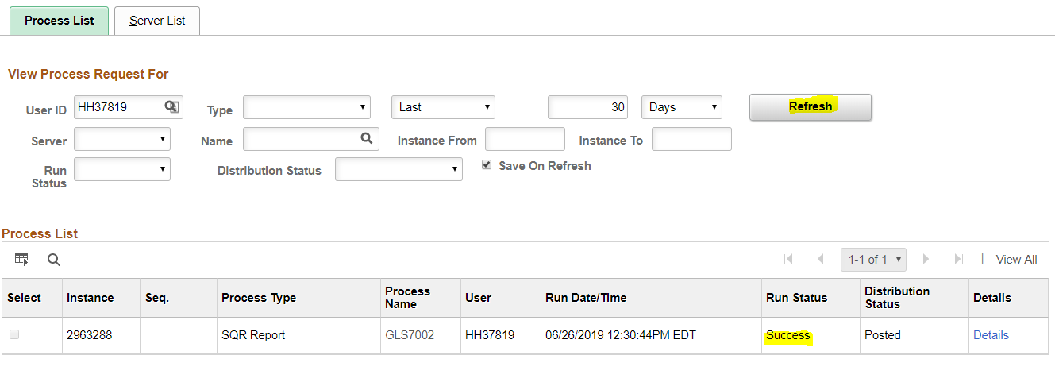
Once the report has run to success, click on the Details link next to the process that was just run.
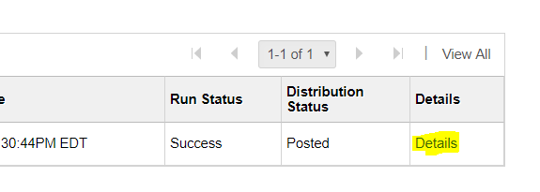

From here, click the View Log/Trace link. This link will take you to the hyperlink of the report.
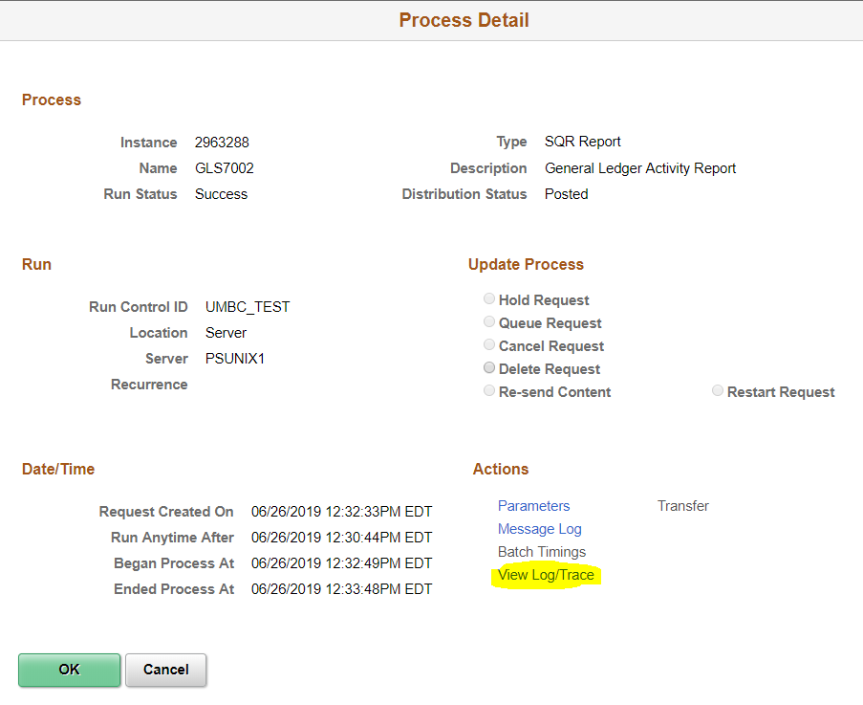
Look for the file that ends in .PDF. Click on the hyperlink to open the file in a new window. From here you can save the file through your browser.

Queries
A query is a tool that allows you to extract data from the PeopleSoft database based on your specified parameters. You can view the data on the screen or export the data to a format that can be customized according to your preferences (using Excel.)
The Queries pagelet can include links to Query Manager, public queries, and pivot grids.
If there is a Query that you think will benefit the campus, you can reach out to IT to have a link added to the Campus Workcenter.
All queries that show up in the Workcenter will be available to everyone, so we cannot configure it for the individual user.
However, you can also view all your query favorites when you go to the Query Manager.

Using a Query
After navigating to the query you need to use (using the Campus Workcenter), you may have to enter search criteria before searching.
As an example, for the query entitled PO Shows Remaining $ on PO lines, you have to specify the PO number.
After entering your search criteria, click View Results.
The results will display on the webpage in a table. You can export these results to Excel by clicking on the hyperlink “Excel Spreadsheet”
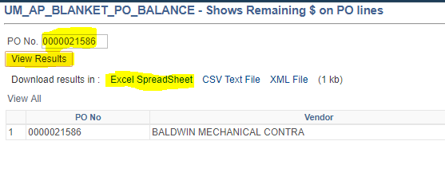

REX Financial Reports

REX Financial Reports is a robust feature of the UMBC REX Data warehouse. Based on the Microsoft reporting platform, the financial reports include payroll and sponsored accounts with drillable hyperlinked data. Reports can be set up as subscriptions and are accessible to non-PeopleSoft users.
There is a monthly training session for REX Finance as well as video tutorials and documentation that can be found on the Financial Services TAP page.

Getting Help

Receiving Updates via E-mail
You will receive UMBC PeopleSoft announcements via e-mail from Financial Services.

UMBC RT Help Desk System
UMBC Technical Staff follows questions and issues using RT Ticket System. For instructions how to enter a ticket, please do the following:
- Go to http://my.umbc.edu
- Click Help -> Request Help
- Enter your myUMBC username and password when prompted and click Login
- Click the New Ticket link located on the left column
- Select a queue which best describes the issue, for example:
  - PeopleSoft Finance - please select Finance Queue
  - PeopleSoft Human Resources - please select Human Resources Queue
  - PeopleSoft Student Administration - please select Student Administration
- Enter a brief but specific summary on the Subject: line, for example, PSUNX Error in General Ledger Report is more helpful than error in PeopleSoft
- Enter a thorough description of the problem, include specifics such as error messages and what was tried to diagnose the problem. You can also take a screen shot of a page or error message and send as an attachment.
- Select a subcategory from the list
- Click Create ticket button
- Review submitted ticket (a copy will also be sent to your email)

Links Associated with PeopleSoft
This section provides the links to websites associated with PeopleSoft (see below.) The Departments section is available on the Departments tab of the website.
- Financial Services
- Business Services
- Human Resources
- Procurement
- Department of Information Technology (DoIT)

Next Steps
Now that you have completed PeopleSoft Finance 9.2 Fundamentals, you are ready to take the next level of courses to build on your skillset.
The training sessions are held monthly and are created as standalone modules. They include:
- How to Buy Things at UMBC
- PeopleSoft Journal Entries
Please register for training on the MyUMBC Training page
Thank you for your participation!

Appendix

Financial and HR Terminology
Below is a list of commonly used terms that relate to financial processing within PeopleSoft.
Job Data: Information used to identify an employee’s title, status, compensation, classification, and benefits eligibility required to generate pay for services rendered, as well as other on/off campus reporting activities.
Personnel Data: Key information outlining employee personal attributes such as name, address, race, birthplace, social security number, citizenship and visa status, veteran’s status, etc. required for University, State and Federal reporting as well as payroll taxation.
Time Entry: Mechanism used by departments to record hours worked, leave taken and other exceptions to employee which ultimately result in payment to the employee.
New Hire Personnel Action Request (PAR): Document used to gather personnel and job data for new employees.
Change PAR: On-line mechanism used by departments to request changes to personnel and job data for existing employees.
Combination Code: A PeopleSoft generated number used by the HR database to encapsulate the Chartfield String used in PeopleSoft Finance and identify funding source for positions/jobs.
Position Management: A term to describe the actions related to the classification and compensation activities within the university.
Department Budget Earnings: Identifies how current and future payroll funds for a position are to be distributed financially across fund sources.
Retro: Refers to the Retroactive Change Form, which is used to modify how payroll was distributed historically.
General Ledger: The final ledger in the financial system which holds all financial transactions used for external and summary financial reporting and financial management.
Commitment Control: Finances that have been reserved for a specific financial transaction, prior to final approval and posting to the General Ledger.
P-Card: Procurement Card – similar to a credit card used for purchases
Project: An event or activity that has a specific beginning and end date.
Grants/Contract: Money awarded to departments by a Sponsor for the purpose of providing products and/or services for a specific project.
State Funded: Money appropriated to UMBC by the State of for the purpose of administering education services to students.
Pre-encumbrance: Money requested to be used for a specific purpose – a Requisition.
Encumbrance: Money approved and reserved to be used for a specific purpose – a Purchase Order.
Journal Entry: Adjustment made directly in the General Ledger
Journal ID: Transaction identification number used to identify Journal Entries. This number appears on budget detail reports and is used to research budget line item details.

Common Navigation Icons
Icon | Function
 | DO NOT use your browser's (Internet Explorer’s) Back, Forward, or Refresh buttons when you are completing a transaction. If you press these buttons while you are in the middle of a transaction, the transaction will not be saved.
 | The Search icon appears on various screens throughout PeopleSoft. The icon indicates that you may select it to display appropriate values for a field. Click once on the icon to select it.
 | The Save button typically appears in the bottom left of the screen. It is recommended that you Save data on the active screen before proceeding to the next screen, or taking another action.
 | The Run button indicates that you want to ‘run’ a specific report based on the search parameters. Note: When the Run button appears, it typically means the information requested output as a Report (to a 3rd party software, such as Adobe Acrobat.)
 | The Fetch button indicates that you want to retrieve data that meets your search parameters and display it at the bottom of the screen. Note: The Fetch button and the Run button are used to perform similar actions in PeopleSoft.
 | Highlighted text indicates that the text is hyperlinked, and if selected, will take you to another screen in PeopleSoft.
 | Process Monitor is used when running reports. Click this link to go to the Process Monitor window to view a list of report requests, their statuses, and links to view the reports.
 | This collection of icons appears in some Retriever Reports when rows of information are collapsed or expanded. Selecting the arrows either expands or collapses rows.
 | The Refresh button refreshes the appearance of a page by updating the description fields for changes made.
 | When this icon appears in a PeopleSoft report, it indicates that the report can be exported to Excel. The icon typically appears on the header row of the report displayed on the screen.
 | The New Window link opens the current window in a new window. If you are performing certain functions in a window in PeopleSoft, you can click the New Window link to open a new window.
 | The Search button is used to return data based on information entered in search parameter fields.
 | Advanced Search displays additional search parameters for a search field.

