Introduction to PeopleSoft Training
Contents
Introduction 3
Security Access 3
Account Information – Chartfields 3
Navigation 5
Logging In 5
Landing Page - Employee Self Service 5
Navigating with Breadcrumbs 6
Navigating with Navigator 7
Workcenters 7
Overview 7
Navigation 8
My Work Section 10
Links Section 11
Queries Section 13
Reports Section 13
Run Controls 13
Overview 13
Creating the Run Control ID 14
Accessing the Reports 15
Approvals 17
Navigation 17
Approve the Transaction 18
Appendix 20
Financial and HR Terminology 20

Introduction
There are three different PeopleSoft environments that you may interact with here at UMBC.
Finance: https://financialservices.umbc.edu
This database stores information related to departmental financial activities. You can use this database to process and locate: P-card transactions, Journal Entries, Grants, Projects, Accounts Payable and Accounts Receivable activities, General Ledger and other financial activities.
Human Resources: https://hr.umbc.edu
PeopleSoft Human Resources, which is used to enter and report on human resource activities, such as Payroll.
Student Administration: http://enrollment.umbc.edu/sa/
Student Administration which consists of Student Recruitment, Admissions, Student Records, Financial Aid, Student Billing, and Academic Advisement

Security Access
Before you can use PeopleSoft, you are granted security access rights into the application. Your security access is dependent upon your role within UMBC. You can be granted several different access rights into PeopleSoft for each database as well as each form or table in the application. The different types of access rights you may receive include:
- No Access: If you have no access to a particular area of the application, you will not be able to see an option on your PeopleSoft work center. For example, if you do not work with Grants, you will not be able to see the Grants menu option.
- View Only Access: if you have view only access to an area of the application, you will be able to see the option on your PeopleSoft menu, but you would only be able to view the information on the screen. Most reports in PeopleSoft are view only, which means you are unable to effect the information in the database, regardless of the buttons or actions you take with the report
- Edit Access: If you have been granted edit access to an area of the application, you will be able to input information into the application. Depending on the level of edit access you have been granted, you may or may not be able to also delete information.

If you require a level of access that you do not have in the application, please complete a Security Access Form and return it to the appropriate team for processing. Instructions for completing the form and where to send it for processing are included in the security form information section of the website.

Account Information – Chartfields
In order to process a transaction in PeopleSoft, users must use codes called Chartfields. Chartfields are informational fields that categorize transactions and apply the transactions to budgets.
A series of chartfields is referred to as a Chartstring. Every action in PeopleSoft requires a Chartfield String in order to submit paperwork and enter, research, and interpret data in the PeopleSoft databases.
Chartfields and Chartfield Strings are required to:
- Generate reports
- Access data
- Perform transactions in PeopleSoft
- Complete forms
- Allocate expenses
When departments make purchases, allocate expenses, and receive revenue, all paperwork associated to these activities requires that the appropriate chartfields be completed in order for the Finance Departments to process the paperwork.
There are 10 chartfields in PeopleSoft Finance, however, not all chartfields are required for every transaction. Some chartfields are specific to grants or sponsored accounts.
For example, chartfields associated to General Ledger transactions are commonly referred to as GL Chartfields. The Chartstring for the GL includes:
- Business Unit
- Department
- Fund Code
- Account
- Prog Fin
- Fiscal Year
The following table provide definitions and examples of commonly used chartfields. If you have any questions about which chart string you should be using, reach out to your supervisor first. They will know more about your specific situation and what is appropriate. Below just lists examples of what to use. The table does not list all possibilities of chart string combinations.
Chartfield | Example | Definition
Business Unit | UMBC1 (all PS 9.2 Finance transactions are under the default) | A set of financial records, business practices and reporting requirements
Department ID | 10118 – New Media | An organizational unit responsible for business transactions
Fund | 1111 = State Fund  1113 = Self Supporting Fund (DRIF)  1253 = Grant Fund | Identifies the source of UMBC funding
Account | Revenue – 4XXXXXX  Payroll – 6XXXXXX  Operating Costs- 7XXXXXX | Classifies business transactions by categories that include assets,  liabilities, net asset (fund balance), revenue and expenditures.
Prog Fin  (Program Financial) | 011- Instruction- General  012 Instruction- Special  021 Research Institutes/Centers  022 Research – Individual | Codes that categorize the expenses. All department budgets have been created with specific Prog Fins to be applied to transactions
Project/Grant | 00000444 CASPR | Provides link for financial transactions to the grant management database
PC Business Unit | UMBC1 for Project Chartstrings  Blank for everything else | Project Business Unit – this is the most commonly generated error. Only populate this if there is a project. Otherwise leave blank.
Activity | MAIN – Non Grants Projects  CNV – Projects that begin with “CV”  BUD001 – Grant Projects | Leave this field blank if you do not have a project.

Navigation

Logging In
To log into PeopleSoft Finance, you can go directly to https://fsprd-web.psfs.umbc.edu/WebAuth
When booking the above as a bookmark, be sure to copy and paste that url directly into the bookmarks toolbar. If you try to favorite after clicking enter, the URL changes and if saved, it will not work as a login link after.
You can also find a link to PeopleSoft Finance on the my.umbc.edu website. After logging in, look for the Trending links just under the main banner in the middle. PeopleSoft: Finance is listed in those links. You can also look for it using the search tool on the my.umbc.edu website.
When logging in, use your normal UMBC credentials.
Please note that PeopleSoft will automatically time out if there is no activity for 120 minutes. It is important that all work is saved before that timeout occurs.

Landing Page - Employee Self Service
The navigation in PeopleSoft 9.2 has seen a drastic improvement in comparison to the 8.9 menu navigation.
In an effort to make PeopleSoft more mobile and user friendly, they have rolled out a menu option of tiles. Tiles mostly point to various WorkCenters, but can also point to heavily used menu options, such as Approvals.
The tiles appear on a page called Employee Self Service. This is the default page you will see when logging into PeopleSoft.
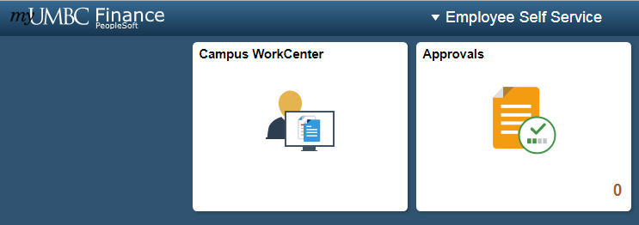
All campus users can use the Campus Workcenter to access everything that they regularly use in PeopleSoft. Departmental Approvers and Central Employees may also see a tile called Approvals.
If you see additional tiles, it means that you have more of a centralized role. Use those tiles to access menu options that relate to central tasks.
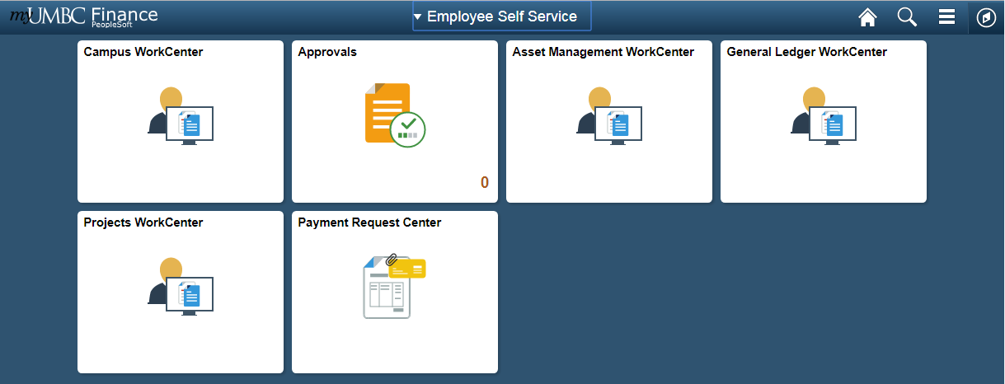
Note: Your WorkCenter is configured based on your security access, therefore there may be less tiles. All PeopleSoft Finance users will have the tile labeled Campus WorkCenter.

Navigating with Breadcrumbs
Once inside a workcenter, you will also notice that a top menu bar appears, showing breadcrumbs of where you’ve been.
This is an interactive bar that shows menu options in the same order as they appeared in 8.9.
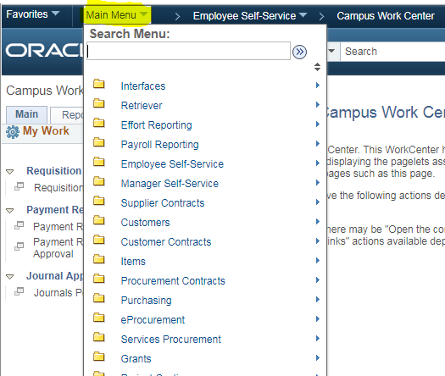

Navigating with Navigator
If you do not see the breadcrumbs at the top of the page (sometimes they are unavailable), you can access the menu options by clicking on the compass symbol called NavBar in top right hand corner of every page. This will bring up a side menu bar.
From there, click on the Navigator Menu option. This will bring up the main menu options in the same order that they appear in 8.9.
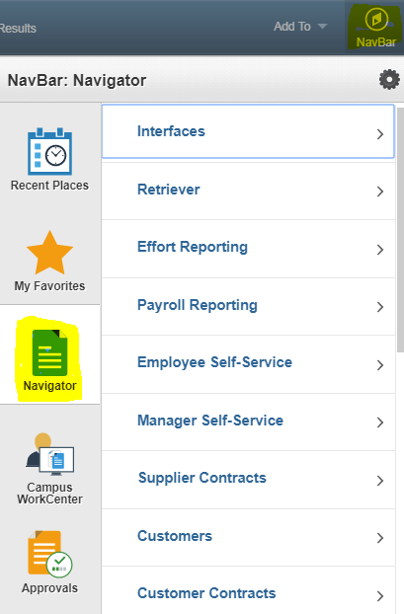
As a general tip, if you drill down to a specific menu option, the next time you go into Navigator it will “remember” the last menu option you drilled down to. So you may have to hit the back bar at the top of the navigator menu tree to see the main menu options again.

Workcenters

Overview
Workcenters are designed to replace the old navigation seen in PeopleSoft 8.9 and before, to group together menu options regularly used based on your role in PeopleSoft. They reduce navigation time and let you accomplish your daily tasks in an efficient manner.

Navigation
All Workcenters are divided into four general areas, called pagelets. On the left-hand side you will see the navigation bar, with two tabs, and two sections on each tab.
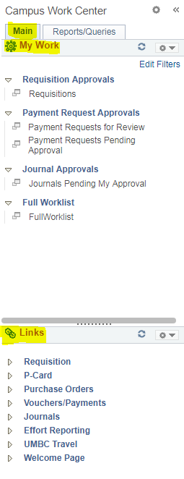
There are additional navigational tools for the pagelets that appear when your cursor hovers in the area: one is a right-hand vertical scroll area. You can left-click the scroll once it appears, hold down the cursor and drag the scroll bar up or down.
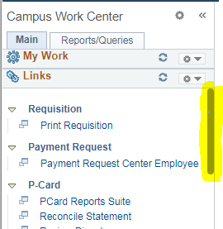
You can also resize each Workcenter pagelet. Just hover over the dotted line in each pagelet until the cursor turns into a double-sided arrow. Left-click and hold down. Drag and drop up or down to resize the pagelet.
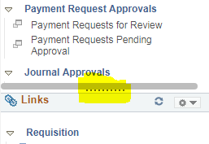
To collapse any of these sections so that you can focus on the sections that matter to you, select the dropdown arrow next to the gear icon, to the right of the section title. Select Minimize.
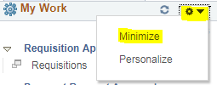
To expand the section, select the dropdown arrow next to the gear icon again, and select expand.
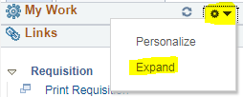
When clicking on any menu item, the page that correlates to that link displays next to the menu on the right hand side. You can hide the left hand menu options to give more real estate for the page you are actively working on. To do this, click on the << symbol at the top of the menu bar next to the Workcenter name.
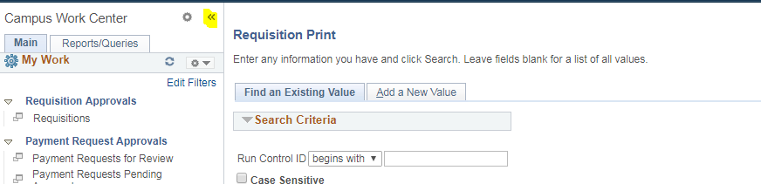
To get the menu back, simply select the >> icon (now in the top left hand corner of the page):
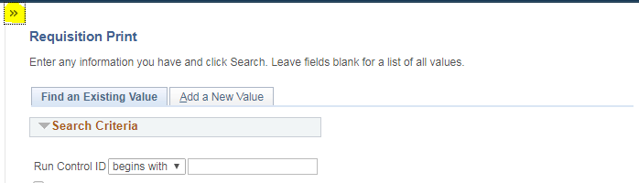

My Work Section
On the main tab, you will see a My Work section with hyperlinks to task pages.
The My Work pagelet can include links to events and notification alerts, prioritized items needing immediate attention, and worklist tasks for workflow approval.
The hyperlinks ONLY become active when you have tasks to complete in that section. Otherwise, the hyperlink is grayed out and you cannot click on it. Hyperlinks are only visible to a user if they have access to the corresponding pages they link to.
When a user has work to do, the hyperlink becomes clickable. A number will display in parenthesis next to the link letting you know how many items require attention in that area.
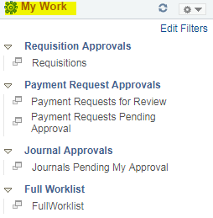

Links Section
The Links pagelet makes it possible for you to access your most commonly-used pages with full functionality without ever leaving your Workcenter.
Each pagelet can include group headings. Group headings are used to place similar pages and links into logical groupings, and are expandable and collapsible.
The group headings themselves are not clickable. You have to select the dropdown arrow next to the group heading to expand the menu options, which opens up all links related to that group heading. Those links are clickable.
The Links pagelet can include additional links to pages and other areas of interest including links that are external to your organization.
You can personalize (from the list enabled by your system administrator) which links appear on your Workcenter.

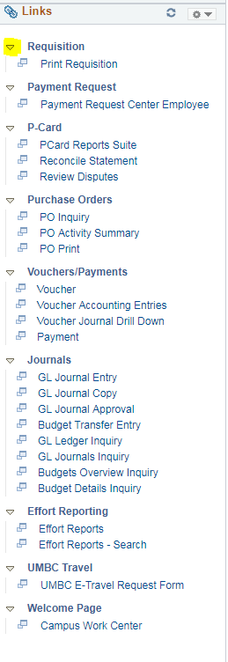

Queries Section
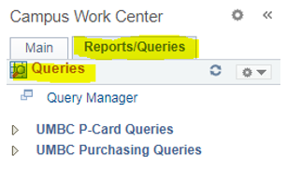
The Queries pagelet can include links to Query Manager, public queries, and pivot grids.
If there is a Query that you think will benefit the campus, you can reach out to IT to have a link added to the Campus Workcenter.
All queries that show up in the Workcenter will be available to everyone, so we cannot configure it for the individual user.
However, you can also view all your query favorites when you go to the Query Manager.

Reports Section
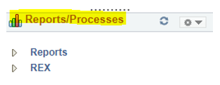
The Reports Pagelet an include links to reports frequently used by the campus. Examples include PCard Reports suite, and all REX reports.
These links take you directly to the Run Control page for the report or process.
There is a REX app that allows you to see and run REX reports within the PeopleSoft environment (only works in Internet Explorer).
If there is a Report that you think will benefit the campus, you can reach out to IT to have a link added to the Campus Workcenter.

Run Controls

Overview
Run controls are required for any process that needs to run. These are snapshots of your data that you input, saved under a Run Control ID. This helps so that you do not have to re-enter the data every time you run that process.

Creating the Run Control ID
When navigating to a report, you will be prompted for a Run Control ID. You can search for an existing one. If you have not created one for this report suite, click on the Add a New Value tab at the top. Follow the following guidelines for the Run Control ID name:
- You cannot use spaces
- Avoid using a year in the ID
- Try to use a name that relates to the report being run.
- These names cannot be changed later.
- Do not use any personally identifiable information in the run control ID, such as your Pcard number. This Run Control ID is a semipublic field within PeopleSoft.

Once the Run Control ID has been loaded or created, you will be brought to a page that allows you enter different criteria for the report. These fields will limit the data that shows up on the report. If left blank, more data will show up on the report. Not all fields are required, but some are.
When finished filling out the applicable fields, select the Save button at the bottom left. This will save the data selected under the Run Control ID you created.
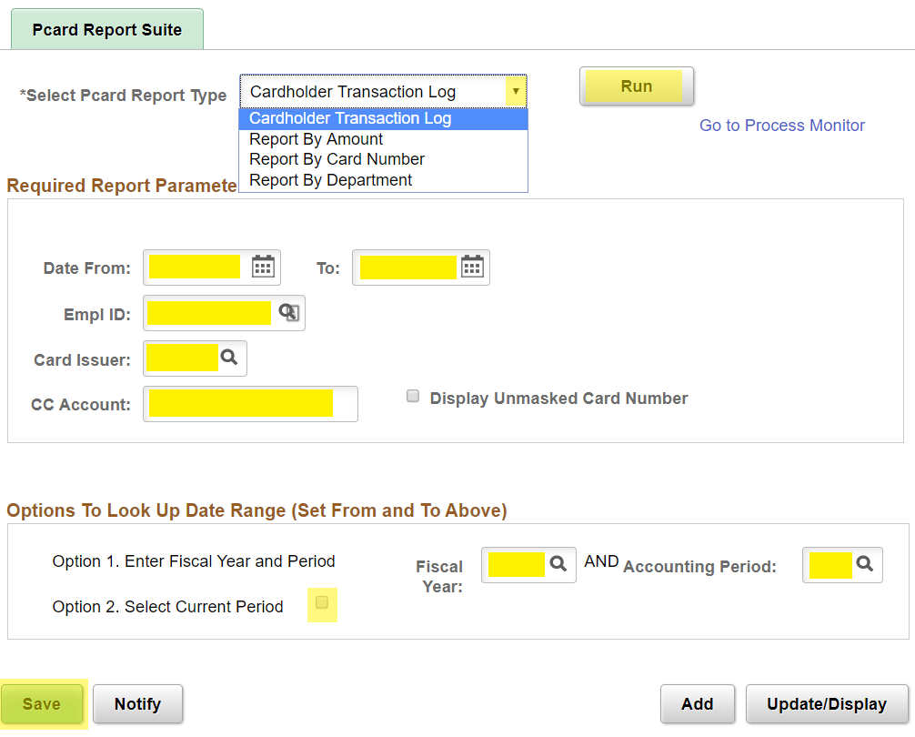

Accessing the Reports
Select the Run button at the top right. The Process Scheduler Request screen pops up. Select OK without changing any of the server information.

The Server Name is automatically populated when the request is saved (PSUNX) or it is blank. Either way, leave the default selections for the servers.

You will then either be brought directly to the Process Monitor or the Run Control Screen.

If brought to the run control screen, select the Process Monitor link at the top right. The process list is displayed.

Make sure most of the fields at the top are blanked out except for the User ID, which should automatically be populated. By filling in these fields, you will limit the processes that are listed below. This can cause you to think the process has not run when it actually has, because it will not display in the list if you limit the criteria.
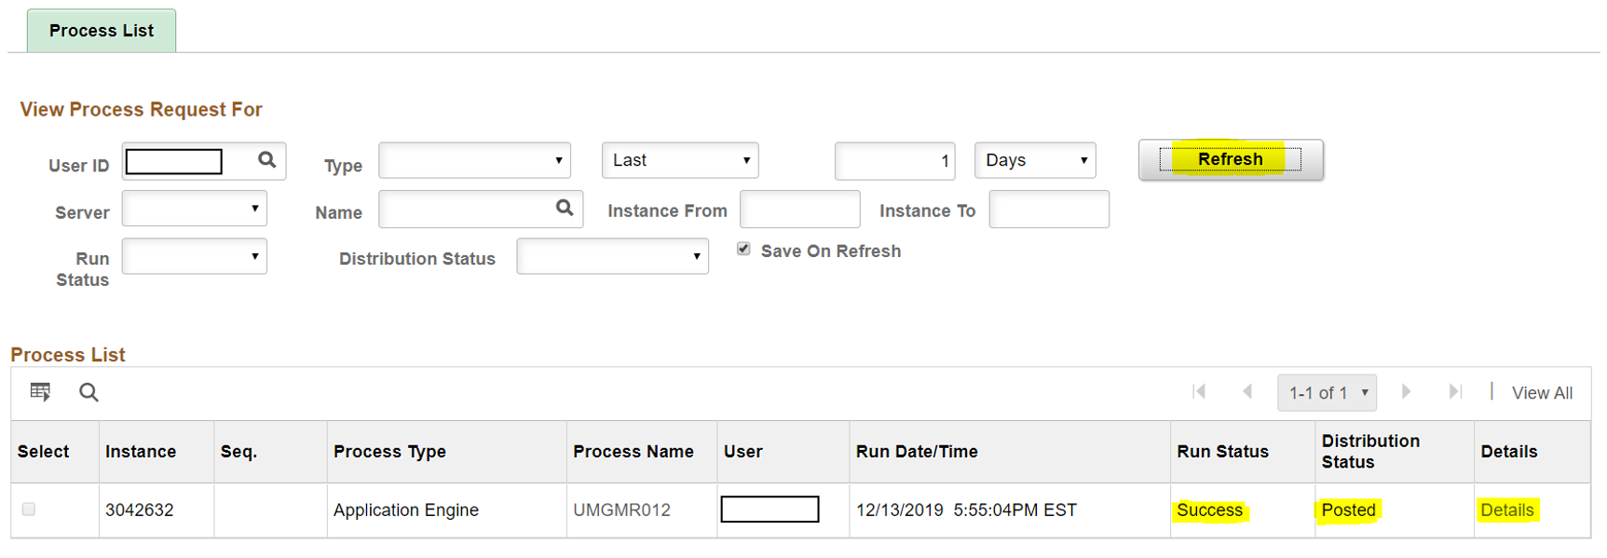

Select the Refresh button periodically until the Run Status changes to Success, and the Distribution Status changes to Posted.
Select the Details link on the right. The process detail page will pop up.
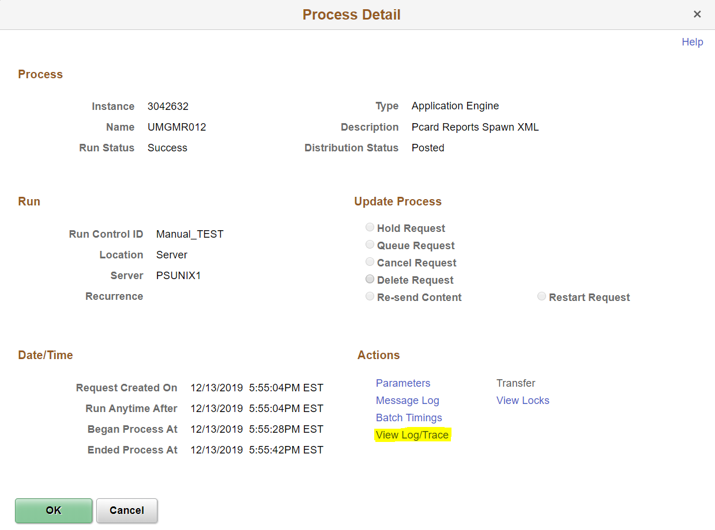

Click the View Log/Trace link listed beneath the Actions column. The View Log/Trace window is opened.
Click the document link that ends in PDF to open the report. Your Adobe Acrobat report will open in a separate window.
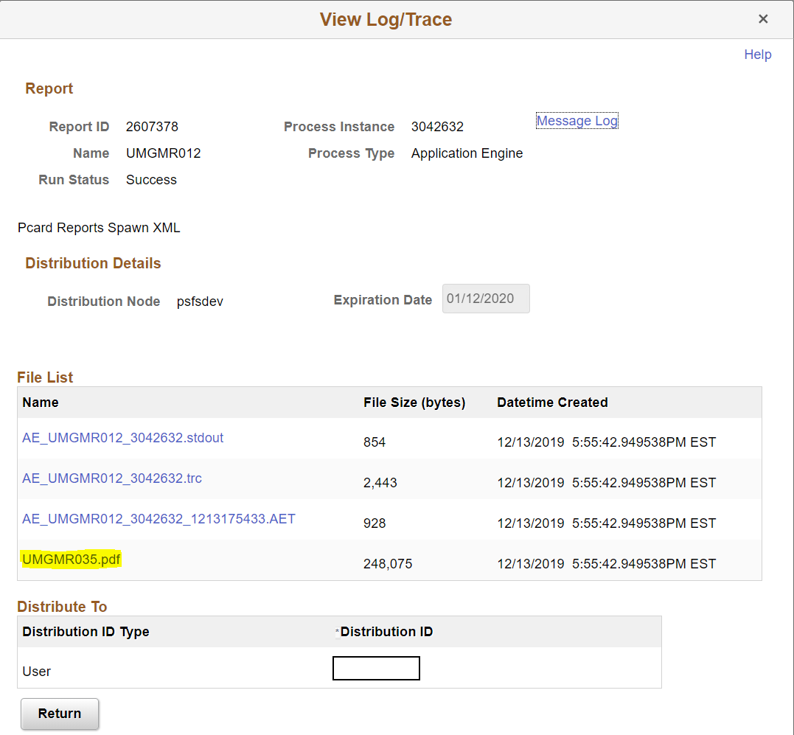

Approvals

Navigation
If you need to approve a Journal Entry as a departmental approver: Go to the Employee Self Service Page and click on the Approvals Tile.
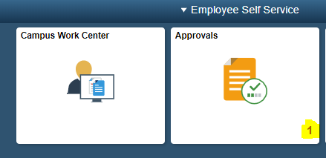
All items requiring your approval are listed here.
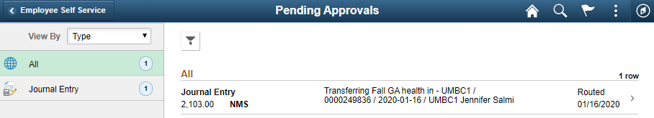
Select the item from the list that you would like to approve. The item name, number (ID) and the person who submitted it can be seen from the review list. Click on the link of the transaction you would like to review.
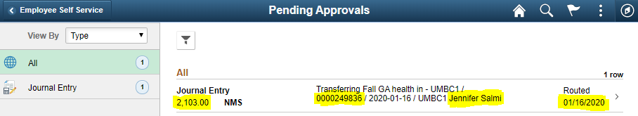

Approve the Transaction
To approve or deny the item, fill in the appropriate comments into the Approver Comments section at the bottom, and select Approve or Deny in the top right hand corner
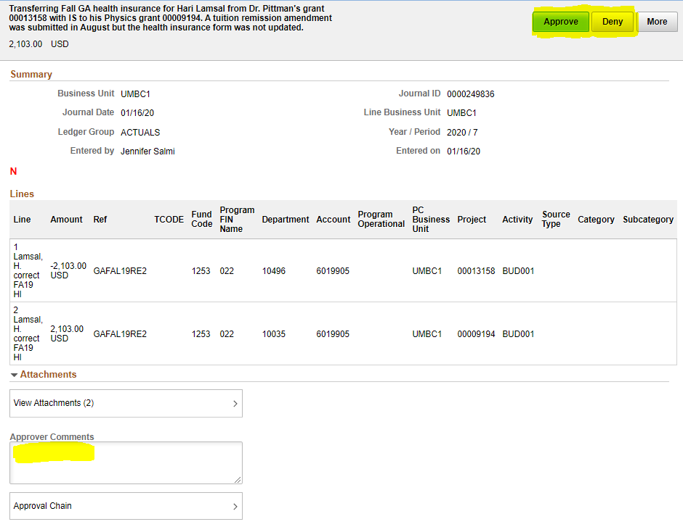
A popup will appear with your approver comments pre-loaded in it. Change your comments if needed. Click Submit.
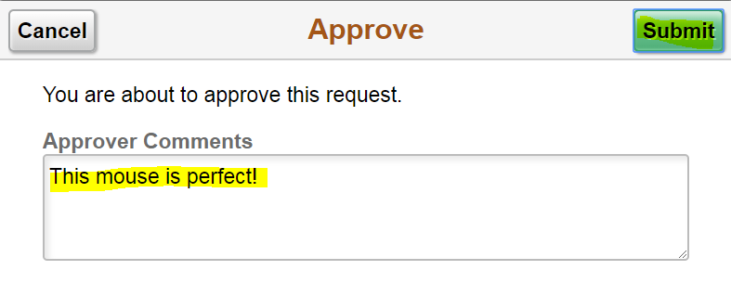
After approving it will go through central approval and disappear from your worklist.

Appendix

Financial and HR Terminology
Below is a list of commonly used terms that relate to financial processing within PeopleSoft.
- Job Data: Information used to identify an employee’s title, status, compensation, classification, and benefits eligibility required to generate pay for services rendered, as well as other on/off campus reporting activities.
- Personnel Data: Key information outlining employee personal attributes such as name, address, race, birthplace, social security number, citizenship and visa status, veteran’s status, etc. required for University, State and Federal reporting as well as payroll taxation.
- Time Entry: Mechanism used by departments to record hours worked, leave taken and other exceptions to employee which ultimately result in payment to the employee.
- New Hire Personnel Action Request (PAR): Document used to gather personnel and job data for new employees.
- Change PAR: On-line mechanism used by departments to request changes to personnel and job data for existing employees.
- Combination Code: A PeopleSoft generated number used by the HR database to encapsulate the Chartfield String used in PeopleSoft Finance and identify funding source for positions/jobs.
- Position Management: A term to describe the actions related to the classification and compensation activities within the university.
- Department Budget Earnings: Identifies how current and future payroll funds for a position are to be distributed financially across fund sources.
- Retro: Refers to the Retroactive Change Form, which is used to modify how payroll was distributed historically.
- General Ledger: The final ledger in the financial system which holds all financial transactions used for external and summary financial reporting and financial management.
- Commitment Control: Finances that have been reserved for a specific financial transaction, prior to final approval and posting to the General Ledger.
- P-Card: Procurement Card – similar to a credit card used for purchases
- Project: An event or activity that has a specific beginning and end date.
- Grants/Contract: Money awarded to departments by a Sponsor for the purpose of providing products and/or services for a specific project.
- State Funded: Money appropriated to UMBC by the State of for the purpose of administering education services to students.
- Pre-encumbrance: Money requested to be used for a specific purpose – a Requisition.
- Encumbrance: Money approved and reserved to be used for a specific purpose – a Purchase Order.
- Journal Entry: Adjustment made directly in the General Ledger
- Journal ID: Transaction identification number used to identify Journal Entries. This number appears on budget detail reports and is used to research budget line item details.

