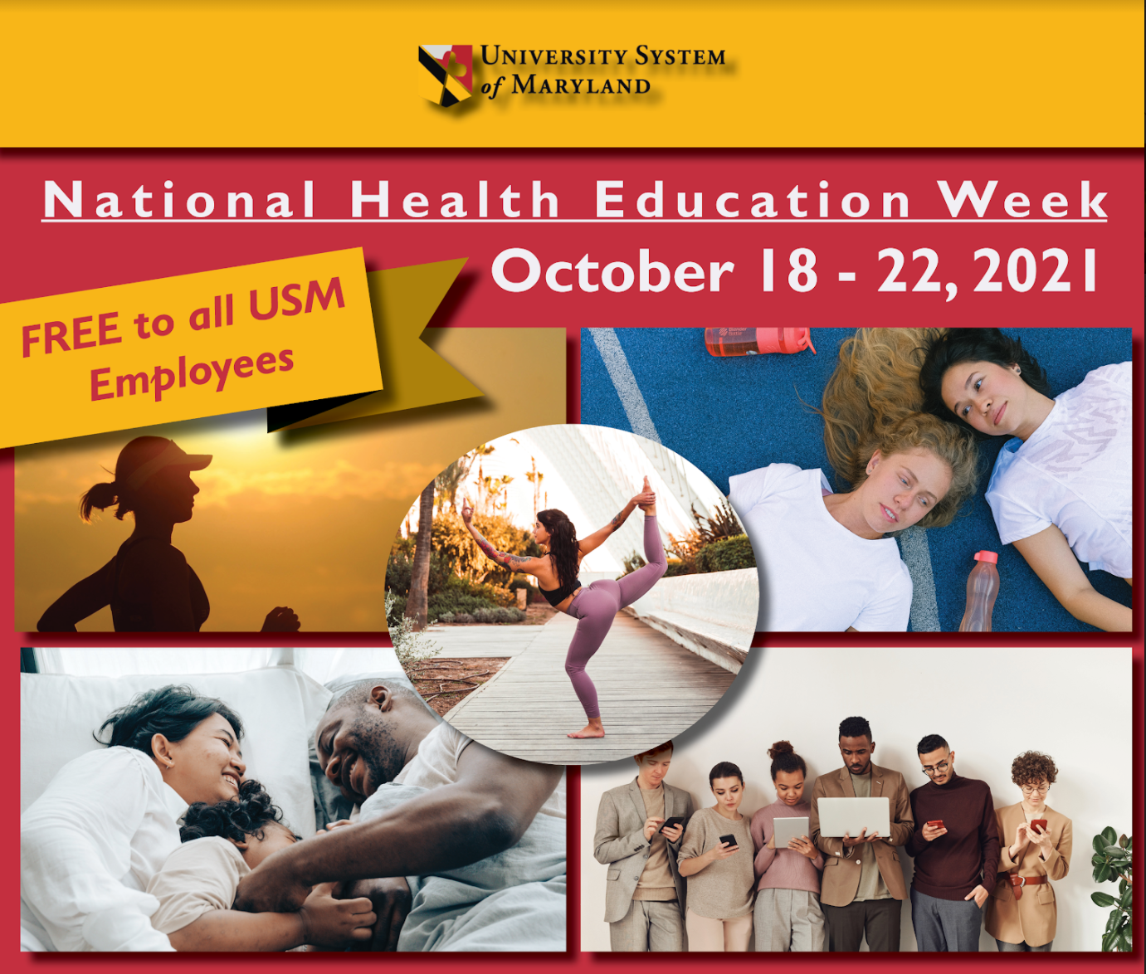

National Health Education Week Launches Today!

National Health Education Week was created in 1995 by the Society for Public Health Education (SOPHE) to focus on increasing national awareness on major public health issues and promoting a better understanding of the role of health education.

Register Now!

What can I expect?
Inspired by SOPHE, the USM Training Committee came together last year in partnership with GuidanceResources® Online to provide all USM employees at no cost health education workshops to address the physical, emotional, and mental health challenges we all face today. This year the committee met and discussed managing stress and anxiety as the most important topics for their employees. So they got together with GuidanceResources® Online to put together the following line-up for this year’s National Health Education Week:

Tuesday
10 am: Tools to Handle Stress
2 pm: Managing Worry and Anxiety

Wednesday
10 am: Healthy Food Choices on the Go
2 pm: Living With Change

Thursday
10 am: Running on “E:” Adding Energy and Fun to Your Life
2 pm: Mindfulness: Being Present in Your Work and Life

Click for more workshop details

So what can I do today?
In the spirit of increasing awareness for the importance of health education, we encourage you to check out these resources and share them with a colleague, a friend, or a family member:

GuidanceResources® Online PDFs:
- Building Better Family Communication: These tips can help you and your family build better listening and communication skills, the first steps in creating a happy home life. Download the PDF.
- Resilience-building Techniques: The key to avoiding the tolls of stress is resilience, which can be strengthened by improving self-esteem, developing a strong social support system, and taking care of your health. Download the PDF.
- Tips for Quick, Healthy Meals: Find great ideas such as brightening up steamed veggies with lemon juice instead of butter, substituting yogurt for sour cream in recipes, and using applesauce instead of oil in baked goods. Download the PDF.

Videos to Watch/Listen
- Lucy Hone: The three secrets of resilient people | TED Talk: To most people in the field, resilience research is a calling, an academic interest, or maybe even just a buzzword. For resilient expert Lucy Hone, it turned out to be an essential survival skill. In this powerful and personal talk, she shares the three strategies that got her through an unimaginable tragedy and—in doing so—offers profound insights on how to find meaning in loss.
- Pico Iyer: The art of stillness | TED Talk: The place that travel writer Pico Iyer would most like to go? Nowhere. In a counterintuitive and lyrical meditation, Iyer takes a look at the incredible insight that comes with taking time for stillness.
- Healing Trauma: The Light Shines Through the Broken Places - Tara Brach: Most of us have encountered trauma either in our own direct experience or with someone in our immediate circle. This talk examines the shame and suffering that arise from trauma and how meditation practices can support a path to full spiritual healing.

I need more!
Challenge yourself to do these three little things this week… we’re going to send everyone who registers for National Health Education Week a quick survey at the end of the week to see what you thought of the workshops and if you tried these three little things to make your week better:
- Try the Maui Habit. Famously outlined in B.J. Fogg’s book Tiny Habits: the moment you put your feet on the floor in the morning, immediately say, “it’s going to be a great day.”
- Make your bed. Admiral William H. McRaven sums up why beautifully in his 2014 commencement address to the graduates of The University of Texas at Austin: “If you make your bed every morning, you will have accomplished the first task of the day. It will give you a small sense of pride, and it will encourage you to do another task and another and another. By the end of the day, that one task completed will have turned into many tasks completed. Making your bed will also reinforce the fact that little things in life matter. If you can’t do the little things right, you will never do the big things right.”
- Write a gratitude list. A daily gratitude list is one of the best (and simplest) things you can do to help yourself have a better day. It will also help you find ways to clarify and focus on what’s important to you, add value to your life, and do more of it! A gratitude list helps us pay attention to the good things in life we might otherwise take for granted.

Register for National Health Education

