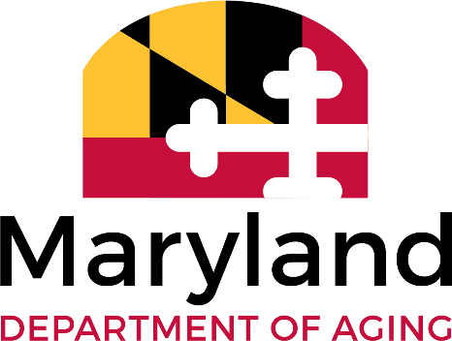
Internship Project Outline
Submitted By: Mark Tesoro Date: 6/17/26 Requested Semester: X Fall ☐ Spring _ Summer
Project Title: Behavioral Health - Extension for Community Healthcare Outcomes (BH-ECHO)

GOAL OF THE PROJECT
The objectives of this project are to -
- Assist in establishing a Behavioral Health focused ECHO by contacting Maryland community-based clinicians and affiliated providers via telephone/electronically to solicit participation in Behavioral Health ECHO professional education sessions hosted the Maryland Department of Aging and the University of Maryland Baltimore Geriatrics and Gerontology Education and Research (GGEAR) Center.
- Attend self-paced video training on the ECHO model used worldwide as well as live virtual training ECHO opportunities to familiarize yourself with the model and are comfortable with the strict format of ECHO sessions.
- Communicate effectively with the Mental Health Association of Maryland to share guidance and resources to inform BH-ECHO.
- Participate in and contribute to regular coordination meetings with the Maryland GGEAR Center and Mental Health Association of Maryland.
- Provide logistical support to the creation, distribution and interpretation of surveying materials used alongside the expert content that will be used to establish agendas and series topics for the BH-ECHO series.
- Coordinate the provider contact information database and assist in distributing and interpreting “Provider Education Interest Survey” (as needed).
- Attend and help facilitate initial BH ECHO professional education sessions, provide feedback and assist in improved delivery.
- Support the ongoing process of hosting statewide provider education sessions to expand provider capacity in early identification, treatment and follow-up of older adults experiencing behavioral health issues and their caregivers.
BENCHMARKS FOR SUCCESS
TIME COMMITTMENT
15-20/hrs. week

EVALUATION PLAN
Initial conference
Evaluation
Follow-up Conference
Final Evaluation
ACTION TO BE COMPLETED | DATE TO BEGIN | DATE DUE | RESOURCES REQUIRED | DESIRED OUTCOME
Call providers and follow scripted dialog to solicit participation in ECHO
Help identify interested providers and electronically distribute “Interest Survey”
Update provider database with active contact information and contact individual
Participate in regular Maryland Dept. of Aging and University of Maryland at Baltimore GGEAR planning sessions.
Support activities in the implementation of clinical provider education sessions for dementia.
Share knowledge gained from communicating with practices and staff of local community healthcare organizations.
NOTES/ADDITIONAL INFORMATION:

