UMBC CREW

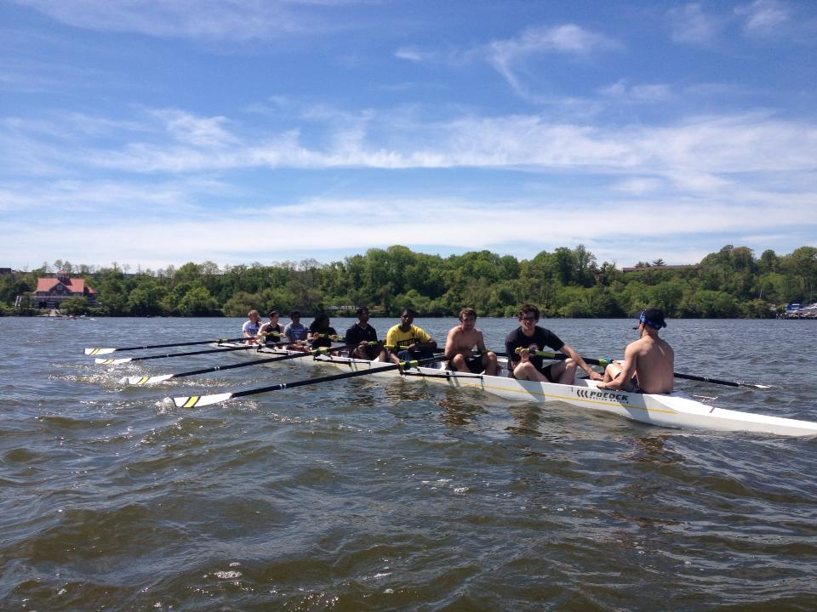 |  | 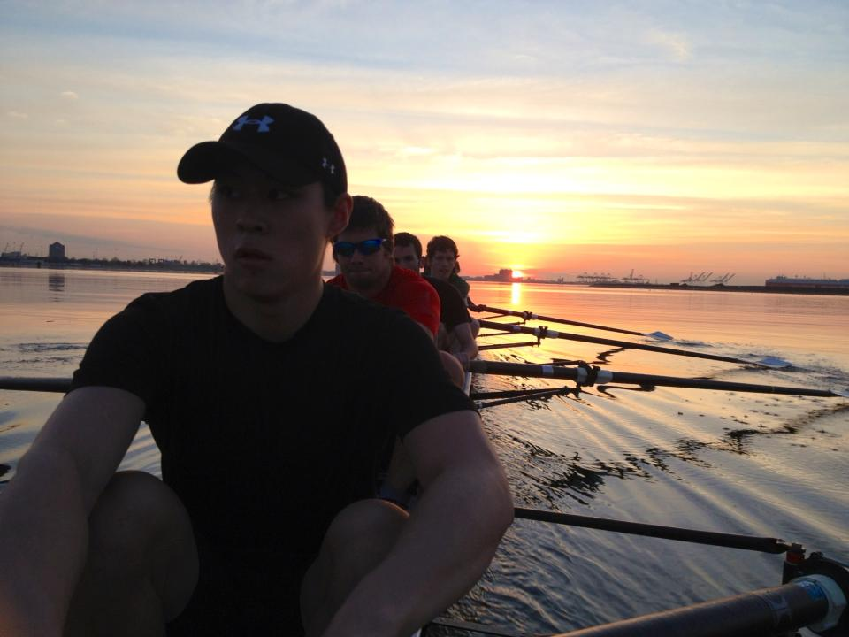

Are you fit? Are you interested in getting fit?
UMBC Crew is looking for motivated individuals to join our competitive team that practices 4-6 times/week

Practice Time (starting: Sept. 3rd):
7:00 PM – 9:00 PM
Be at the UMBC RAC (gym) in your spandex on the track by 7:00 PM for an informational meeting and introductory practice.

**No experience needed, we will teach you everything you will need to know.

For additional information or questions contact:
Coach Adam- adestefano11@gmail.com
Payton LaRocque- Lar1@umbc.edu
Margie Emond- mae1@umbc.edu

