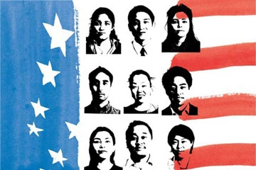
http://tinyurl.com/jeaz23p

This is an event that will focus on taking a deeper look at the election results and what followed. All in context to Asian Americans and people of color. Allies are welcome.

Join us Wednesday, Dec 7th, 2016
Sond 206 from 6-8 pm to discuss what has happened in context to Asian Americans on and off campus.

Our lead speakers will be :
Tamara Bhalla and Theodore Gonzalves
(Faculty American Studies - UMBC)

Refreshments will be served.

Event co-sponsored by: UMBC FASA and Student Life’s Mosaic Center.

