NAU_Logo1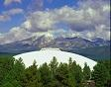**The Department of Psychological Sciences**

**Northern Arizona University**

Announces

***Summer 2016 Undergraduate Research***

***Internships In The Social Psychophysiology of Compassion***

At our beautiful Mountain Campus in Flagstaff, Arizona

June 4 through August 1, 2016

Application Deadline March 15, 2016

**A 40-hour/week research-intensive internship in the following potential areas:**

**Psychophysiology of compassion, anxiety, and stress**

**Social goals, friendship, and happiness across cultures**

Compassion, attention, creativity, and decision-making

**Anxiety, depression, compassion, and cardiovascular health**

**Functional analysis of compassionate parenting and child-rearing**

**Electrocortical (EEG) and psychophysiological correlates of compassion**

**Role of compassionate behaviors and diversity in the work-life interface**

**Cross-cultural compassion, perceived similarity, identification, and The Quiet Ego**

**How compassionate relationships affect the self-concept and the cognitive structure of the self**

**Mirror neurons, empathic resonance, and electrocortical manifestations of compassion and cruelty**

**Internship includes:**

Individualized research collaboration with Department of Psychological Sciences doctoral faculty

Creating and presenting a professional conference presentation, with an opportunity for manuscript submission

An opportunity for a paid year-around research internship

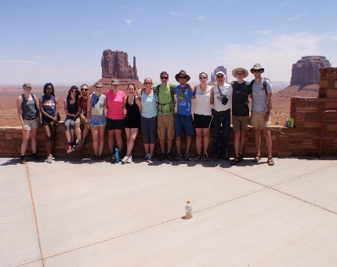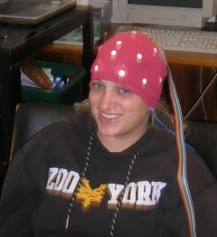Travel support to and from Flagstaff and partial conference travel

A **$4000** Stipend

A **$550** Laboratory allowance

6 Credit Hours PSY 485 Tuition Paid

Picnics, lunches, recreational travel around Northern Arizona

And much, much more . . . .

Funding provided by

The National Science Foundation (NSF)

Research Experience for Undergraduates (REU) Program

Northern Arizona University

Vice President for Research

Provost

College of Social and Behavioral Sciences

Department of Psychological Sciences

For further information and to apply, please see our website at

<http://www2.nau.edu/~psych/StevensREU/reu.html>

or email Dr. Larry Stevens at [Larry.Stevens@nau.edu](mailto:Larry.Stevens@nau.edu)

With the subject identifier “REU”

Or call (928) 523-6530