Wellness Wednesday

Creative Self-Care: Enso Mantras
Wednesday, September 4, 2019 · Noon - 1 PM
Joseph Beuys Sculpture Park

Interested in finding simple yet impactful ways to weave wellness into your professional and personal life? If so, please join faculty and staff colleagues for Wellness Wednesdays. Each session offers information, resources, and/or immersion into different wellness modalities that are supported at UMBC.
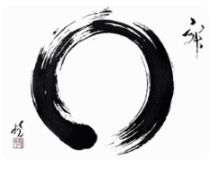
Join us in the Joseph Beuys Sculpture Park for another mindful artistic experience led by Jill Wardell, Director of Workplace Learning, OD & Wellness and Sandra Abbott, Curator of Collections & Outreach for the Center of Art, Design & Visual Culture.

In this 1-hour wellness session, you will learn the meditative art of Enso (circle) painting, a sacred Zen calligraphy symbol from 6th century Japan that symbolizes the connectedness of existence, strength, the universe, and the imperfect as perfect, among other things. Painting Enso is traditionally accomplished in one movement that is coordinated with the breath and is said to be a reflection of the state of the painter's mind in that moment.

To prepare for painting Enso, participants will be lead through a mindfulness meditation to assist with quieting the mind, arriving to the present moment, and embodying a state of peacefulness. Participants may accompany their Enso with a self-care inscription or mantra to act as an anchor for moving through the stressors of daily life.
Co-sponsored by Human Resources and the Center of Art, Design & Visual Culture.

Rain location for this event is Engineering 023.

Space is limited and registration is required. Registration deadline is Friday, Aug. 30.
If you register for a workshop and your attendance plans change, please email us at hrtraining@umbc.edu.
Please arrive early so we can begin promptly at 12:00 noon.

