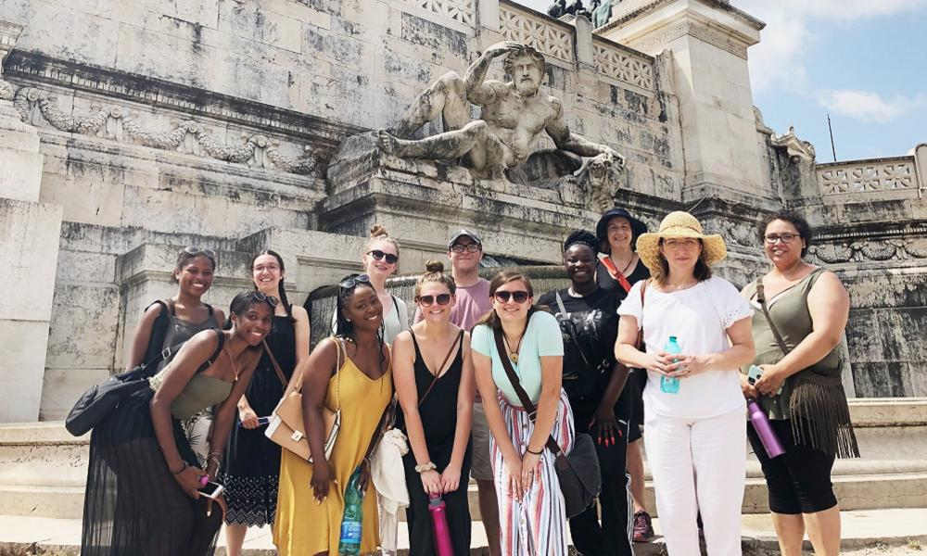

UMBC Visual Arts Study Abroad Program - Summer 2023

Picturing Italian Art and Culture in Context
Rome, Italy, July 3 – July 28, 2023

This program includes two Visual Arts courses, ART329/ART216 Roman Visual Culture and ART369/392: Mobile Imaging in Italy, for a total of 6 undergraduate credits. Both courses engage the rich history and architecture of Rome, analyzing and exploring it through writing and creating art using mobile technologies.

Both courses can be used to fulfill the following requirements:

- For the BA/BFA in Visual Arts, ART216/ART329 will fulfill requirements for the Art History portion of all VA concentrations. ART216 can be used as an Arts and Humanities or Culture credit.
- For the BA/BFA in Visual Arts, ART369/392 will fulfill requirements for the Photography concentration or it can be used to count as an art elective in other VA concentrations
- For Global Studies majors, the program fulfills the Study Abroad requirement
- Both courses can be used to fulfill requirements for general electives

These courses include these field trips to:
- Pompeii and Herculaneum
- The Colosseum and Roman Forum
- Ara Pacis
- The Sistine Chapel
- The Vatican Museum
- St. Peter’s Basilica
- The Borghese Gallery
- The Pantheon
- Borromini’s San Carlo alle Quattro Fontane
- Bernini’s Sant'Andrea al Quirinale
- St. Agnese Catacombs
- Capuchin Crypt
- MAXXI Museum of Contemporary Art
- Cinecitta Film Studios
- The MACRO Museum

For more information about the classes, contact:
Lynn Cazabon, cazabon@umbc.edu
Kimberly Anderson, akimber@umbc.edu

The faculty will be giving an information session for this program on Tuesday February 14, noon – 1pm in FA342. Register to attend.

PROGRAM COST: $4978
- UMBC tuition is waived. Airfare and personal expenses not included. For advising and questions about scholarships and financial aid, contact educationabroad@umbc.edu

APPLICATION DEADLINE: FEBRUARY 28, 2023

APPLICATION GUIDELINES
Please note: admissions will be considered on a first-come first-served basis, so apply early if you can!

