ART 427/691 - Museum Practice – Spr 2019
Wednesdays 1-3:30 pm, FA 342
Museum Practice students visit the The Walters Art Museum conservation labs
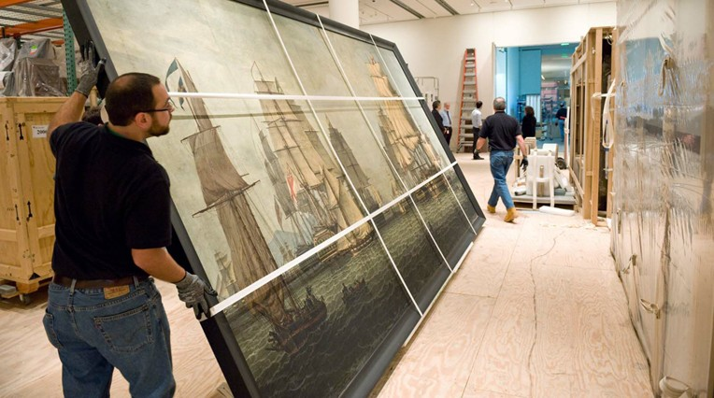
This project-based course includes several museum/gallery visits and the opportunity to curate an art exhibit in the community.

In some cases pre-requisites may be waived with consent of instructor. Contact instructor for permission or with questions at abbotts@umbc.edu.

