

Homecoming 2023

Location
On Campus
Date & Time
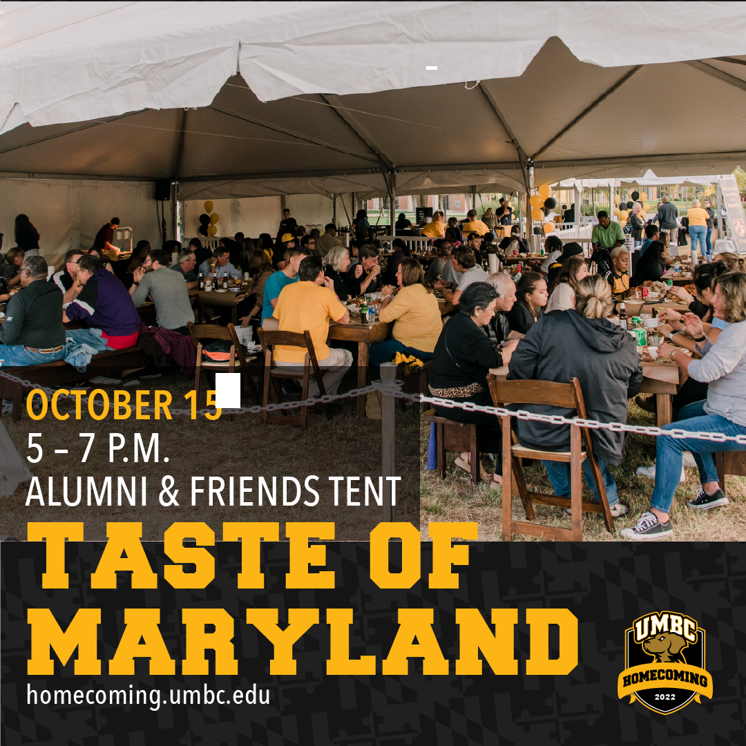
October 8, 2023, 12:00 PM – October 14, 2023 5:00 PM

October 8, Sunday Taste of Maryland, Women’s Soccer
Homecoming is bringing back the Taste of Maryland - crabs, crab cake, beef, chicken from 4-6:30 ($) Gather some of your colleagues and sign up. You must sign up for this on the Homecoming website since there is a fee and a limit of participants. We are trying for a WI table or section of one. Let Joan know so we can coordinate a reservation (jcostello@umbc.edu).
Register for Taste of Maryland HERE.

October14 , Saturday - UMBC Homecoming
The Wisdom Institute is excited about having a greeting table in the Affinity tent (smaller tent by the Alumni tent) from 12 - 1:30 pm. Please stop by for a visit with fellow retirees and share future suggestions.

October 14 - One of the best events is the GRIT X Talks (Global Research Innovation Trends + Excellence), that celebrates the achievements and research of alumni, faculty and graduate students. Attend the event on Saturday 2-4pm in the Fine Arts Recital Hall; the talks will also be posted to UMBC YouTube within days of the event. Perhaps we can have a zoom meeting in January to discuss the talks and possibly have one of the presenters attend. This will be listed on the WI site at a later time.

Other events we highly recommend:

October 14 -The Founding Four Group (the first four graduating classes) has published This Belongs to Us, a compilation of stories from our first students (retirees Bob Dietrich, Bryan MacKay and Joan Costello wrote stories) will be hosting a brunch, 10am to noon ($10) and reading some of the stories You must register on the Homecoming site. The event will be in the Commons Skylight Room.


And there is always the puppy parade and carnival.

Check events on the Homecoming site - https://homecoming.umbc.edu for more information and to sign up for them.

